Dog Walking Induction

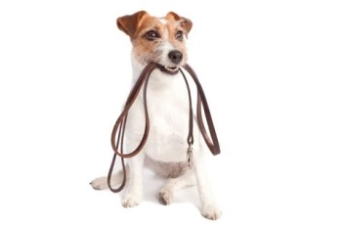

Welcome
Why do we need a dog walking induction and why do we have strict procedures which need to be followed? Mistakes can happen; these mistakes have previously led to prosecutions against Pets Haven and Directors of the charity. You will read and learn about these prosecutions throughout out the induction and with the materials supplied.
You will need to know about how to safely interact with the dogs that you will be walking or providing other dogs walkers, volunteers and potential adoptees with our procedures. Our induction includes:
- information on correct walking techniques,
- what to do in an emergency,
- general dos and don’ts to help you get started.
- The importance of following rules due to prosecutions held against Pets Haven
Also involved is a practical demonstration of how to correctly fit check chains and leads.
Walking our dogs is a heart-warming experience but can also be physically challenging. Whilst we have a variety of big dogs and small dogs some of our dogs are very strong and quite boisterous. You will need to be able to maintain a strong grip on their lead and must be able to control the dog at all times.
Instructions relating to the individual behavior of various dogs specific care is handwritten on the dogs sheltermate kennel card. You must be able to read these instructions and make notations of your own if there any matters that may need to be bought to our attention, please ‘hand write’ notations and verbally speak to the shelters duty manager.
You will be supplied with Pets Haven’s walking procedure manual. You must refer to our manual at all times.
Walking a dog should not be an awkward experience, if you follow Pets Haven’s procedures; you and the dog that you are walking will have an enjoyable time.
The induction gives you the chance to ask any questions that you may have. Often people are slightly worried about what may be asked of them so this is a good chance to put your mind at ease.
Please follow our procedures, protect the dog you are walking, the community, community members dogs, cats, property and Pets Haven.
Let’s get started
Walking your personal dog is something that you do without really thinking of incidents which could occur. You know your dog but the dogs at our shelter are not your personal dogs and they are all very different.
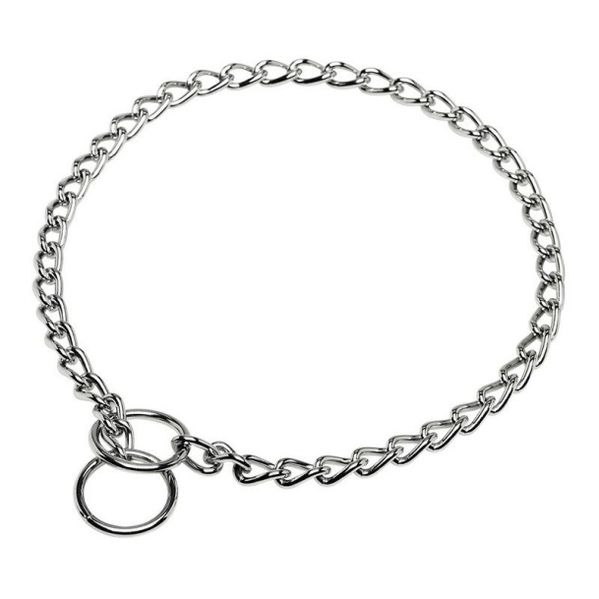
We know that all of our dogs are temperament tested prior to arriving at our shelter. The temperament test happens from our pound partners and employees. A dog’s temperament can change depending of their surroundings; this is why it is crucial that our dogs are monitored daily and observations are made whilst walking. You must also be very clear with anyone who wants to walk one of dogs, it is imperative that you go through all of our procedures, before you let anyone walk a dog.
When walking a dog, noting that we only ever walk one dog at a time, a check chain must be used. A dog can never be walked without a check chain and a secure lead.
A check chain [refer to the photo] provides the security we need when walking a dog. A check chain will never become lose, un-clip or ‘accidently fall off’. You may not personally like or use check chains yourself, though this is a safety requirement that you must follow.

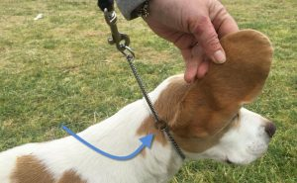
How to put on a check chain. The proper way to put on a check chain is to put it in front of the dog so it looks like a horizontal 'P.' The leash is attached to the ring that does not have the collar sliding through it. From the leash then, the collar runs over the TOP of the dog's neck and then around to the other ring.
You must ensure that the lead which is attached to the check chain is strong, not broken and is latched on securely. Due to a previous incident where a lead was accidently dropped and the dog escaped from the handler, you must double the lead around your wrist for extra security.
NOTE -Please ensure you take stool collection bags with you on every walk in case your dog toilets whilst be walked.
General Do’s and Dont’s
- Do: Pick up after our dog. It is just rude to leave a steaming pile where someone might step.
- Don’t allow our dog to trample through someone else’s garden. While it’s obviously harmful to the plants, the plants may also be harmful to our dog.
- Don’t: Dogs should not relieve themselves on other peoples’ gardens, either. It’s inconsiderate to allow our dog to urinate on someone’s beautiful flowers or plants.
- Do restrict meet and greets. Though we like our dogs to make new friends, not every pet owner welcomes distractions on their walks. Don’t allow our dog to go up to someone else’s dog at any time. You must ensure that you do not interact with any community member’s dogs. If you are walking past a house, please ensure our dogs are kept away from cats.
- The same goes for people. Don’t let our dogs go up to every person he sees. You must ensure you stay clear of all community members. Even though you may think our dog is amazing, we can never be 100%.
- Subsequently, don’t go up to other people’s dogs, we have stated this throughout our induction. A dogs behaviour can be unpredictable.
- Do: Always use a check chain and a secure lead. Whilst our dog might look like a social butterfly and perfectly well behaved, you cannot assume that of every other dog you pass. Seeing a dog off-leash may also make other people (or dogs) nervous or anxious, ensure you are responsible by removing our dog from a possible altercation.
- Do: ensure that our dog walks alongside you and is never off leash or out of your control.
- Do: Make sure you remove yourself from busy areas [local parks, shopping strip, schools]. It makes it difficult and it is annoying to other pedestrians to have to move around our dog when he is taking up the entire walkway. Be aware of others and respect other pedestrians’ space. Keep to our general rule of keeping as far as you can away from community members and their pets.
- And of course, do enjoy yourself! For some dogs, this is their only time to get out so make the best of it by showing them new places and smells once in a while instead of the same boring routine day after day. Safety for our dogs and community members must be our first priority.

Emergency situations
If an emergency happens whilst you are walking a dog please follow the below instructions.
A dog has a seizure; let the dog rest, try and secure the dogs environment, call the shelter for assistance on 5427 3603. If you do not have a mobile phone, ask a local person for assistance in calling the shelter.
We live in Melbourne, weather conditions change! If the weather turns for the worst, cease your walk and return to the shelter immediately. Please ensure dogs are not walked when we are experiencing high temperatures, rain or hail.
If a dog somehow breaks free from you, you must try and locate the dog. You must call the shelter immediately. Do not return to the shelter without trying to secure the dog. If the dog cannot be located, we must report the dog as missing to our local council.
If our procedures are followed, there should never be a reason for an altercation between two dogs, though if an altercation does occur, you must intervene, control the situation, ask for the persons details [if present], call or return to the shelter immediately.
Procedures are in place to ensure that our volunteers and employees enter and exit the kennels in an appropriate and controlled step-by-step manner. For your own safety and for the safety of our animals, volunteers and employees must be able to fully understand and follow directions, adhere to our processes, and do so without supervision.
We hope that you can appreciate our need to ensure that all of these criteria’s are met, but if you have any queries at all please address them with management at Pets Haven.

The importance of following rules due to prosecutions held against Pets Haven.
Pets Haven has provided our walking procedures for many years now. There are signs and posters throughout the facility in advising staff, volunteers and dog walkers of our walking procedures.
We know we are working with animals and incidents can occur. We also know that sometimes human errors can happen. The issue is, when incidents happen they can have serious legal repercussions.
Pets Haven has decided in providing staff, volunteers and dog walker’s examples of what has legally happened to Pets Haven due to two incidents which occurred in 2015.
Incident [1] July 2015
A dog was in Pets Havens care for 31 days. This dog showed no signs of aggression; he was handled numerous times daily, walked and played with. A dog walker was walking this dog and the dog did bite an elderly man.
Was the dog walker paying attention to the dog that was being walked?
~ Not being present when the incident happened, we can only assume that the walker was handling the dog correctly. Though on the other hand, if the walker was in total control of the dog and followed our procedures, this incident may not have occurred. You must hold a dog in tightly and not just be oblivious when you are walking.
Why did the dog bite the elderly man?
~ We cannot really answer this question. The dog was in our care for 31 days, he showed no adverse signs in our care. Though, we need to go back to the walker’s control of the dog when being walked. If the walker was in control this incident may not have occurred. It is so important that our dogs are not walked near community members or community dogs.
Why would Pets Haven and the Director of the charity be prosecuted?
~ Local Council has the right in prosecuting Pets Haven Foundation under Section 29 of the Domestic Animal Act [S29] ‘refer to the following pages for explanation of what Section 29 actually means.
What was Pets Haven prosecuted for?
The dog did bite the elderly man, therefore Pets Haven and the Charites Director was issued with a prosecution for the following
S. 29(4) amended by Nos 44/2010 s. 10, 55/2011 s. 4(2).
(4) If a dog that is not a dangerous dog or a restricted breed dog, attacks or bites any person or animal and causes death or a serious injury to the person or animal, the owner of the dog, if not liable for the offence under subsection (3), is guilty of an offence and liable to a penalty not exceeding 40 penalty units.
Is this fair, reasonable or ethical?
~ It does not matter what ‘we think’ the simple fact is that an incident occurred and liability of that incident becomes the responsibility of Pets Haven. The stress and financial repercussion’s that incidents like bear cannot be tolerated. Walking a shelter dog should not lead to this situations. You must follow our walking procedures.
Incident [2] November 2015
A dog was taken from the correct exit of our shelter, the dog had the required collar and lead on. The dog became tangled between the walkers legs [the dog was extremely timid]. The walker was trying to untangle the lead; unfortunately, the walker accidently dropped the lead. The dog then escaped from the walker. After chasing after the dog, the dog eventually out ran the walker. The walker and volunteers searched for this dog for many hours, the following days which turned into to search parties throughout many weeks. There were alleged sightings, though to no avail.
This dog was on the run for approximately 5 weeks. It has been alleged that the dog killed three sheep. This dog was shot by a local farmer and identified by local council as being the missing dog from Pets Haven. This dog was reported to local council the day the dog disappeared.
How did the dog break free from the handler?
~ accidents, mishaps and incidents happen, in this case the lead simply slipped from the dog walkers hand.
The owners of the sheep did not want to prosecute, so why is Pets Haven being prosecuted?
~ Local council has the right in prosecuting Pets Haven Foundation and the Director of the charity. The Director of the charity must take full responsibility, even if it is a simple mishap such as someone dropping a lead. The repercussions of the ‘lead being dropped’ resulted in three sheep allegedly being killed by this dog.
What was Pets Haven prosecuted for?
S. 29(4) amended by Nos 44/2010 s. 10, 55/2011 s. 4(2).
(4) If a dog that is not a dangerous dog or a restricted breed dog, attacks or bites any person or animal and causes death or a serious injury to the person or animal, the owner of the dog, if not liable for the offence under subsection (3), is guilty of an offence and liable to a penalty not exceeding 40 penalty units.
What does 40 penalty units mean?
It can mean up to 6K per incident, in these particular cases there were 4 charges.
[1] The incident with the elderly man
[2] Three sheep were allegedly killed – one charge per sheep.
Total possible fine of up to 24K.
Upon the current revision of our induction dog walking procedures, these two cases had not been heard in court. Once the verdict has been determined, the outcome will be inserted in the next revision of this induction.

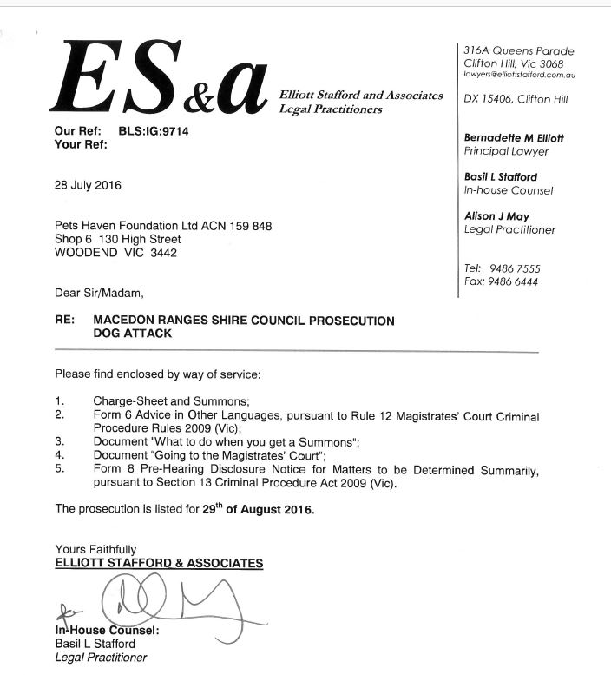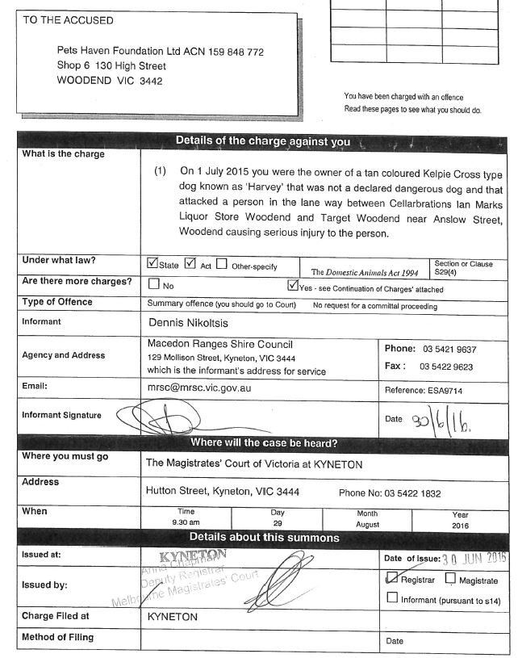

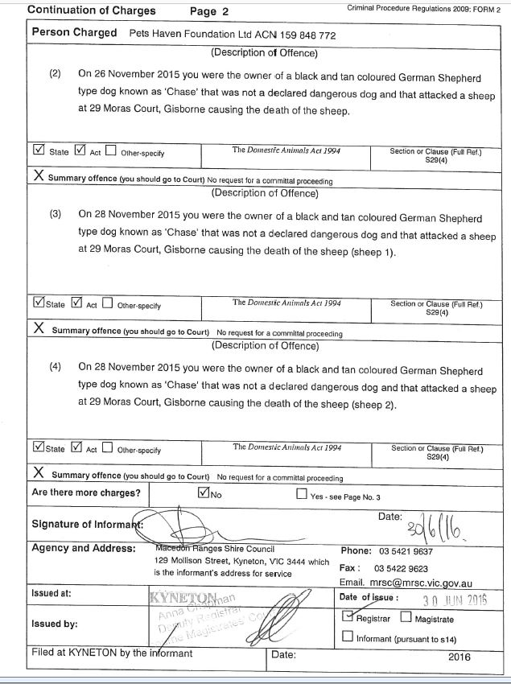

DOMESTIC ANIMALS ACT 1994 - SECT 29 Offences and liability relating to dog attacks
S. 29(1) amended by No. 55/2011 s. 4(1).
(1) If a dangerous dog, that is not a guard dog guarding non-residential premises, or a restricted breed dog attacks or bites any person or animal, the person in apparent control of the dog at the time of the attack or biting, whether or not the owner of the dog, is guilty of an offence and liable to a term of imprisonment not exceeding 6 months or to a fine not exceeding 120 penalty units.
S. 29(2) amended by No. 55/2011 s. 4(1).
(2) If a dangerous dog, that is not a guard dog guarding non-residential premises, or a restricted breed dog attacks or bites any person or animal, the owner of the dog, if not liable for the offence under subsection (1), is guilty of an offence and liable to a term of imprisonment not exceeding 6 months or to a fine not exceeding 120 penalty units.
S. 29(3) amended by Nos 44/2010 s. 10, 55/2011 s. 4(2).
(3) If a dog that is not a dangerous dog or a restricted breed dog, attacks or bites any person or animal and causes death or a serious injury to the person or animal, the person in apparent control of the dog at the time of the attack or biting, whether or not the owner of the dog, is guilty of an offence and liable to a penalty not exceeding 40 penalty units.
S. 29(4) amended by Nos 44/2010 s. 10, 55/2011 s. 4(2).
(4) If a dog that is not a dangerous dog or a restricted breed dog, attacks or bites any person or animal and causes death or a serious injury to the person or animal, the owner of the dog, if not liable for the offence under subsection (3), is guilty of an offence and liable to a penalty not exceeding 40 penalty units.
S. 29(5) amended by No. 55/2011 s. 4(2).
(5) If a dog that is not a dangerous dog or a restricted breed dog, attacks or bites any person or animal and the injuries caused by the dog to the person or animal are not in the nature of a serious injury, the person in apparent control of the dog at the time of the attack or biting, whether or not the owner of the dog, is guilty of an offence and liable to a penalty not exceeding 10 penalty units.
S. 29(6) amended by No. 55/2011 s. 4(2).
(6) If a dog that is not a dangerous dog or a restricted breed dog, attacks or bites any person or animal and the injuries caused by the dog to the person or animal are not in the nature of a serious injury, the owner of the dog, if not liable for the offence under subsection (5), is guilty of an offence and liable to a penalty not exceeding 10 penalty units.
(7) If a dog rushes at or chases any person, the person in apparent control of the dog at the time the dog rushed at or chased the first-mentioned person, whether or not the owner of the dog, is guilty of an offence and liable to a penalty of not more than 4 penalty units.
(8) If a dog rushes at or chases any person, the owner of the dog, if not liable for the offence under subsection (7), is guilty of an offence and liable to a penalty of not more than 4 penalty units.
(9) In any proceeding for an offence under this section, it is a defence to that offence if the incident occurred because—
(a) the dog was being teased, abused or assaulted; or
(b) a person was trespassing on the premises on which the dog was kept; or
(c) another animal was on the premises on which the dog was kept; or
(d) a person known to the dog was being attacked in front of the dog.
(10) In any proceeding for an offence under subsection (3), (4), (5), (6), (7) or (8), it is a defence to that offence if the incident occurred as part of a hunt in which the dog was taking part and which was conducted in accordance with the Prevention of Cruelty to Animals Act 1986 .
(11) If a person is found guilty of an offence under this section with respect to a dog the court may, in addition to any other order made by the court, order that the person pay compensation for any damage caused by the conduct of the dog.
(12) If a person is found guilty of an offence under this section with respect to a dog, the court may order that the dog be destroyed by an authorised officer of the Council of the municipal district in which the offence occurred.

Over view
- Practical
- Collect stool bags
- Use of check chain
- Attaching check chain to lead
- Ensure check chain and lead is secure
- How to handle lead and dog – to the left of person’s body
- Exit and Enter via the back of the shelter
- Ensure no other dogs are approaching or are near by
- Watch the dog’s body movements
- Ensure the dog is kept away from community members and their dogs. Do not walk in busy areas, stay away from parks, schools, shopping strips, keep away from peoples gardens.
- If our dog sees another dog [from a distance] and starts barking, control the dog with a firm voice and pull in tightly with the lead. The check chain will help control the dog.
- Always monitor what the dog is doing. Whilst walking a dog it is always a great opportunity in finding out if the dog has any previous obedience training. Ask the dog to sit, shake, note if the dog walks well on a lead or requires further training.
- When returning our dog, ensure there are no other dog’s returning or leaving for a walk. You must keep all dogs separate at all times.
- Ensure that the dog is securely placed in his pen before un-latching the lead.
- Provide any notions about your observations when walking the dog.
- If an incident has happened on your walk, ensure all details are reported
- The importance of following procedures – Legal repercussions for the charity and Directors.
- You will be supplied with Pets Haven’s walking procedure manual. You must refer to our manual at all times.
- By following all procedures and understanding your responsibilities and the repercussions that an incident can have, you should now be fully equipped in walking a dog without any foreseeable issues.

Twelve Dog Walking Procedures

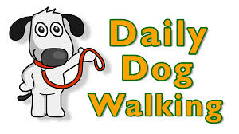
1] Choose a dog that is suitable for you to walk
2] Ensure that you have the right size check chain and strong lead
3] Approach the kennel run calmly; ensure you have control of the door so the dog cannot escape
4] Ensure that there are no other dogs being removed from kennels or being brought back before you remove your dog
5] Ensure that one dog is being walked ‘one’ at a time
6] Dogs are not allowed to be walked at the park or in high traffic areas
7] Dogs are allowed to be removed and returned from the shelter from our back gate exit only
8] Dogs are NEVER allowed off lead
9] Dogs are not allowed to meet other dogs on walks, you must observe your surroundings and cross paths as to ensure community dogs and shelter dogs do not meet
10] You must take stool bags with you, collect any mess a dog may make and return full stool bag to Pets Haven’s rubbish bins
11] You must report any behavioural issues to Pets Haven staff or managers that may be on site.
12] Never allow children to run up to our shelter dogs

I _______________________________________ have read and understood the contents of this induction ‘Dog walking procedures. I will ensure that I follow these procedures. If I am responsible for allowing a dog to be walked by a dog walker I will ensure that all the required dog walking procedures are clearly explained and complied with.
Please ensure that our ‘’dog safe walking cards’ are issued to all dog walkers and that the dog walking register is completed by all walkers and/or volunteers.

