Fostering an animal is not a lifetime commitment

It’s a commitment to saving a life

Foster Care Information Kit

About Pets Haven
Pets Haven Foundation is a not-for-profit organisation (non-government funded) which re-homes orphan felines and canines who would otherwise have no future. Our highest value is "pro-life". We rescue from death row pounds, cruelty cases, puppy farms and the community. We endeavour to responsibly rehouse these orphans back into the community in order to give them a second chance at life.
Every case is unique and each animal is managed according to their particular circumstances and current condition. Animals that do not require rehabilitation are kept at the shelter whilst awaiting their forever home, whilst those in need of medical attention are placed into approved foster homes with all medical provisions paid for by Pets Haven. When the animal has recovered and is in good health, it will then be placed up for adoption.
Animals that enter Pets Haven have generally been mistreated, are malnourished, abused or neglected and often require extensive medical treatment which is always provided to ensure a full recovery. Our foster carers help immensely in that they provide a wonderful, safe and loving home environment so that the rehabilitation process can be successful.
Each and every animal that comes through Pets Haven is vet checked, desexed, vaccinated, microchipped, wormed, given flea treatments, scanned for ringworm and dogs are even tested for parvovirus. Furthermore, each animal is temperament tested prior to its arrival at the shelter. Our dedicated staff and volunteers spend time getting to know them so that they can help prospective adopters make an informed decision as to whether that particular animal would be suitable for them. If a Pets Haven professional does not think an adoption is appropriate, it will not proceed. Ensuring that the animal will be rehomed into a suitable environment, lifestyle and family is our greatest concern. These animals have already experienced enough pain and uncertainty and thus require a home that will last a lifetime.

Our Contact details
Address Pets Haven Foundation 6/130 High Street Woodend Vic
Shelter T 03 5427 3603 E shelter@petshaven.org.au
PH Clinic T 03 9729 5444 E clinic@petshaven.org.au
Foster care coordinator M 0417 424 818 E fosterfriends@petshaven.org.au

Emergency Protocol and Contact Information
On occasion, foster animals have medical emergencies that happen outside of the normal hours of operation. In the case of an after-hours medical emergency, please contact the Foster Care Coordinator at 0417 424 818. If she is unavailable, please follow the emergency chart. We will assist you in getting the animal the attention he or she requires.
The contact person will direct you to either meet them at the clinic where they will administer the appropriate care. Please note that if you decide to take the foster animal directly to an emergency veterinary facility, we will not be responsible for any of the costs incurred.
Under no circumstances should the afterhour’s emergency numbers be contacted when the shelter or clinic is open. The afterhour’s mobile is not manned during working hours.

Welcome
Pets Haven Foundation welcomes you as a new Foster Parent!
Thank you for considering opening your heart and home to one of our shelter’s homeless animals. Your generosity will provide young and old, injured and sick, pregnant abused and under socialised dogs and cats a chance to grow and heal before their forever homes.
It really takes a special person to be a Foster Parent. Many animals end up at Pets Haven Foundation due to no fault of their own. Many of these special animals need the TLC that only a Foster Parent can provide. Your love and attention can get our animals back on track and boost their chances of being placed in a permanent, loving home. Being a Foster Parent is a truly rewarding job.
The rewards, however, are not without their challenges. When our animals are rehabilitated or when they are ready for adoption, finding a loving home of their own. You will undoubtedly become attached to your foster pet and it may be very difficult to give it up.
When you return your foster animal to the shelter, it may be difficult for you to see your foster pet in the shelter environment, especially after having all the comforts of your home whilst living with you. It is important to remember that you have been a part of this animal’s journey is making him or her adoptable, and that you can trust the staff at Pets Haven Foundation to find the best possible home for your foster friend.
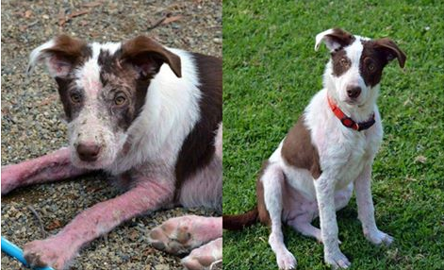
There are unfortunate risks involved in fostering animals and it can be a very painful experience for you. You must be aware of and prepared for these possible, though unlikely, outcomes. A dog might be fostered because it is not at present adoptable. For the majority of these dogs, the special care you provide will be decisive and they will become healthy and ready for adoption. There are those few who, in spite of your best efforts, will not become healthy, well-adjusted pets. Pets Haven is also guided by very strict legislation which we must abide by. The staff at Pets Haven may have to make the very difficult decision to euthanise such dogs. Sometimes puppies or kittens may also pass away in your care. This manual includes Foster Program Policies and Guidelines for our volunteers, and will provide you with fundamental information about fostering for Pets Haven Foundation.

What do we have a Foster Care Program?
The foster program gives animals that are not currently ready for adoption another chance for Pets Haven Foundation to secure their rescue. Our animals, for one reason or another, require short term foster care until the time comes when they can be released back into the shelter and made available for adoption.
WHAT KIND OF ANIMALS NEED FOSTER HOMES
- Puppies or kittens too young to be adopted
- An abused dog or cat that needs socialisation and tender loving care
- A dog or cat recovering from surgery or other injuries
- An abandoned mother with a litter of kittens or puppies
- Any animal when the shelter becomes over crowded or a huge rescue is happening
How long does a dog remain in a foster home?
It completely depends on the animal and situation. The average stay in a foster home is two – three weeks. However, some animals may only stay a few days and others may stay for a few months.
If, on the other hand, you take home a pregnant cat or dog, you will need to keep them until the kittens and/or puppies are old enough for adoption, which is a significant length of time. At the time you are contacted about fostering an animal, you will be given an estimated return date.
Clear goals will be set from the beginning so that both the foster family and Pets Haven Foundation understand the goal being worked towards for each particular animal whether that is rehabilitation, socialisation, recovery from illness, that the animal is old enough to be weaned/adopted, etc. A general period will be set up for the estimated duration of the foster.
Will my dogs or cats health be jeopardised?
It is always a health risk to expose your animal to other animals, whether at the off-leash areas, the vet waiting room, or the common animal areas. But if the foster parents’ own animals are current on their vaccinations, maintain a healthy diet and lifestyle, and are not elderly or very young – and therefore their immune systems are not compromised – then the health risk is minimal. If you or someone in your household is immune-compromised, consult your doctor before fostering. If you or someone in your household is pregnant, talk to your doctor before fostering cats. Working or living with animals exposes humans to a group of diseases called zoonoses. A zoonotic disease is defined as a disease transmitted from animals to humans and also from humans to animals. Proper hygiene, preventative measures and an understanding of these illnesses can reduce the risk of disease.
What kinds of dogs and puppies are fostered and why are they fostered?
We will only place dogs that are potentially adoptable into foster homes. They are frequently fostered because they fail to meet our minimum age requirement for adoption. They may be fostered because of minor health problems or because they’re recovering from a surgery or an injury. Sometimes we foster dogs because they are having difficulty coping with the kennel environment. In all instances the expectation is that after a reasonable time in foster care, they will be ready to be placed into a permanent adoptive home.
What is the foster parents’ responsibility while the dogs or puppies are in their care?
As foster parents it is your responsibility to provide reasonable and proper care of the dog while it is in your home. They require the basics of water, food, exercise, adequate confinement, and, of course, lots of socialization and love. You may be required to administer medication according to instructions.
What kinds of cats and kittens are fostered and why are they fostered?
Cats and kittens that are fostered through Pets Haven Foundation for various reasons. Many cats arrive pregnant, unweaned kittens, kittens without mothers and scared kittens [at this stage, we do not rehabilitate feral adult cats]. They may be fostered because of minor health problems such as cat flu or because they’re recovering from a surgery or an injury [eye removal, amputation ect]. Sometimes long term cats have difficulty coping within the shelter environment. In all instances the expectation is that after a reasonable time in foster care, they will be ready to be placed into a permanent adoptive home. Please only consider fostering kittens if you have the time to spend with them. It is pointless fostering kittens or scared kittens if you will not spend time with them.
What is the foster parents’ responsibility while the cats or kittens in their care?
As foster parents it is your responsibility to provide reasonable and proper care of the cats and kittens whilst they are in your home. They require the basics of water, food, adequate confinement, and, of course, lots of socialization and love. You may be required to administer medication according to instructions.
What happens at the end of the foster time?
If the animal in your care is fully vet worked and is ready for adoption. The animal must be brought back to the shelter where they will be placed up for adoption. All adoptions must take place at the shelter.
If you have an animal in you care [litter of kittens/puppies, un-desexed Mother]. You may be asked to drop the animal[s] off directly to one of our veterinary partners or other arrangements may have been organised between you and our Foster Care Coordinator.
How do I become a foster parent?
You will need to complete a foster care application and fully understand the commitment which is required. Once you are accepted you will be given access to our private FaceBook foster page.
Foster Care - Frequently Asked Questions
How do I find out what dogs are available to foster?
The very best way to be informed about what type of animals require fostering is to make sure that the Foster Care coordinator has your current e-mail address and a correct contact number for you.
How do I arrange to foster animal from Pets Haven?
Once you’ve been accepted as a foster carer, you’re ready to take someone home with you. When you respond to an e-mail, telephone call or FaceBook post and find there is an animal that needs you, just set up an appointment to pick up your foster animal.
What if I have children?
Fostering is a wonderful family experience and can build a foundation of philanthropy in your children. It’s important to select a dog that is “age” appropriate with your children, and as a general rule, children under16 years old should NOT be left alone and unsupervised with any dog. You must also be diligent about providing guidance, instructions and rules to your children about caring for an orphaned dog. Children should not be left unattended with puppies and kittens in case they accidently drop or hurt one of our fur babies.
If I have my own animals, can I foster dogs and cats?
Yes, but keep in mind that it’s always a health risk to expose your animal to other animals whether it’s walking at parks, vet waiting rooms or other common animal areas. The health risk is minimal if your animals are not aggressive, current on their vaccinations. We also need to ensure that a proper introduction is conducted, dogs should NEVER meet on your property, and they need to meet on neutral territory, like a park or in your street. You should never introduce dogs ‘face on’ as if something was going to happen, it will happen at that split second. Please never break our rules and assume everything will be alright. If for some reason you feel that your resident animal and your foster pet are not getting along, you must spate them immediately and contact the shelter or our Foster Care coordinator. Do not place your dog or the foster dog or cat at risk.
My dog loves all other animals; he will be fine with another dog.
Just like people, not everyone gets along. Bearing in mind that we often do not know the past history of an animal we are saving. You must take caution and not ‘assume’ that there may be an issue, this way you will always be prepared.
I’m going away for the weekend, what can I do with my foster pet?
Although you should always try to take foster animals only when your schedule allows you to care for them until they are ready for adoption, there will be times when unforeseen circumstances (either with your schedule or with the animals readiness) makes this impossible. You must contact our Foster Care coordinator, giving us a little bit of notice, so we can find another carer.
I think my foster animal needs to see a veterinarian, what do I do?
Call our Foster Care coordinator and discuss the problem. We can decide the best course of treatment, and if deemed necessary, arrange a vet appointment. You may be asked to drop your foster pet off at our Vet clinic and return to the clinic when your foster pet is ready. We do not encourage foster carers to stay at our clinic in case decisions have to be made which are not favourable. Additionally our Vets are very busy and like to directly deal with Pets Haven instead of numerous foster carers.
Why do you desex your animals at such a young age. I thought 8 weeks was too young!
Early age desexing is common and safe, and it makes much more sense to spey and castrate before they reach reproductive age. Many foster parents are a nervous wreck the first time they take a litter of little ones in for their operations. What they find though, is that the younger our cats and dogs are, they recover more quickly from surgery, and have fewer complications afterwards. In fact, they seem to bounce back much faster than animals that are desexed at an older age.
How do I set up a space for my foster pets? Where should I put them?
As a general rule, the space should be quiet, comfortably warm and have food, water, toys, and a nice place to sleep. For puppies, a crate and an exercise pen are recommended. For adult dogs that are ill or injured, or simply need time away from the shelter, a properly sized crate is a good thing to have on hand. For pregnant mothers a quiet warm space away from your other pets and children.
You don’t need anything too elaborate. As long as the animals are safe, secure, clean and around humans for socialisation. Some foster parents use a spare bedroom or bathroom. Others set up a pen in the middle of the family room. The type of space you set up will be influenced by the type/age of animal you will foster, and whatever their special needs may be.
How much time each day is needed to foster?
Commitment and responsibilities depend on the individual animal and situation. It’s essential that foster parents understand that shelter animals may be stressed and moving the animal from the shelter to the foster home is also very stressful and emotional. Foster parents must be willing to be patient and commit time to the animal; our goal is to keep them in a stable and consistent environment.
If you have kittens we do expect that they are handled daily and played with. It is pointless in putting newborn kittens in your laundry and not handling them, this defeats the purpose of fostering.
How long is it okay for the foster animals to be left alone?
No more than a normal working day of 8 to 12 hours. However, this will depend strongly on what needs the type of animal you are fostering.
If you’ve got two week old kittens or puppies without a mother, you’re going to need to bottle feed them every couple of hours along with the cleaning and socializing. A dog that comes to your home because the shelter is too stressful but has no problems with separation anxiety can probably stand to be without you as long as you would let your own dog be alone. In short, it will depend on the type, age, and temperament of the dog you choose to foster. There’s something for everyone!
Why do I need to separate my pets from the animals I foster?
Primarily to protect the health of your own animals, as well as to prevent any behavioural disputes between fosters and resident pets. In the case of long-term foster care, foster dogs are often integrated into the “family", and usually this works out well.
In the case of fostering for illness, it is best to keep family pets and fosters separated until the sick animal has been cured and can safely become part of the family until its return to Pets Haven Foundation for adoption. You also may not be able to anticipate how your family pets will respond to new animals in your house and vice versa. Certainly, once you’ve had the animals long enough to know if anybody’s sick, there may be some advantage to introducing fosters to permanent family members.
For example, if you can tell prospective adoptive parents that your puppies are used to cats or other dogs or children, you’ve opened up more potential homes for them.
Can I take my foster dog to an off-leash dog park for exercise and socialisation?
No. You are not allowed to take any foster dog from to an off-leash dog park.
While these parks can be fun for some dogs, there are far too many unknowns for it to be a safe and healthy experience for a foster dog. Diseases are easily transmitted and the temperaments of visiting dogs are unknown, thus creating a huge liability to Pets Haven Foundation. Also, taking a leashed dog to a dog park can create barrier frustration and aggression in dogs.
You cannot take your foster dog anywhere off leash – beach, park, families property ect
What will Pets Haven provide for me if I become a foster parent? (i.e., medication, food, supplies, etc?)
If your foster animal requires medication, we will provide you with the required medication. The Foster Care Coordinator will advise where the closet pick up point is. If your foster animal becomes unwell, you need to make immediate contact with our Foster Care coordinator. Please try and be vigilant by monitoring your foster animals health and behaviour. It is really hard if we are told that a foster animal is sick when our veterinary clinics are closed! Though should your foster animal become un-well after hours, you still need to contact Pets Haven. Our Vet visits are scheduled with our Vet partners only; you will not incur those fees.
When you first take a foster animal we can provide you with food, bedding, and toys. Many people who foster have the required resources, though if you require anything to assist you with your foster animal, please advise our Foster Care coordinator.
Though we do ask, if you choose to feed our animals yourself, please do not use a plain label pet food, as there is simply no nutrition.
We do have various locations where medications, Divetalac, worm/flea products plus other supplies can be collected.
Do I have to give updates about my foster animal?
Yes, your updates are crucial, you can update using our FaceBook Foster page, or telephone, text or email to our Foster Care coordinator. We require, at the minimum a weekly update.
Why are you asking me to take photos of animals in foster care?
Foster carers have animals in their care who are looking for new homes. The photos we place on our website, are what attracts their new owners. We need our Foster Carers to take photos, you do not need a professional camera [though if do you have a good camera, that's a big bonus]! Please read a few of our tips and why we need clear photos. We often ask for clear, face front and clutter free photos so we can use them for stories on our main FaceBook page or for advertising the cat or dog on our website. We need clutter free photos ` taking photos of cats or kittens with a kitty litter tray in the background or dirty bedding is not exactly something we could use. Photos were there may be rubbish, a dog sitting on wet concrete, dirt, scared, tied up, puppies/kittens with dirty faces . A ‘no connection’ photo [not looking into the camera or side shots] cannot be used either. Photos that are blurry or have 'red eyes' are not useable. If you have a look at our website you will see the quality we require. You do not need to be a professional photographer to take a nice photo, you just need patience and to settle the animal in their surroundings. If you take a foster dog outside for a quick photo and think the dog will immediately pose for you, this may not happen! Let your foster dog outside, let him/her walk around, let them become relaxed and then try and take a photo - have a squeaky toy close or treats. Watch your surroundings, noting that these surroundings will be in your photo. Oh and photos must be landscape.
What is the procedure if I decide to adopt my foster dog?
When the dog is ready for adoption and has not been allocated to an Adoption Event. It is really important that you advise Pets Haven Foundation that you want to keep your foster animal. An adoption fee is still applicable. By advising Pets Haven Foundation, that you wish to keep your foster animal on the day that he or she is due back, this maybe too late. Please always keep our Foster Care Coordinator up to date with your wish to adopt.
I know it will be hard for me to bring back foster dogs. What can I do?
Every foster parent has a different way of approaching this. Here are some of their tactics: “Go into the Foster situation with the attitude that the animals are "on loan" to you. Realise that you are only their "babysitter" for a short while. Recognise the fact that if you choose to adopt too many of your fosters, you won't be able to foster anymore. Realise that someone else will love them just as much as you do, and they will be equally happy in their new home. All you can do is acknowledge that fact going in and know in your heart that there will be a perfect adoptive home for them out there once you do all of your hard work! If you choose to take them back to the shelter for adoption, rest assured that the staff will take care of finding the right home for them.”
Are foster animals ever euthanised?
Much energy, love, time and vet care is devoted to our foster animals, and the shelter is committed to finding homes for ALL the adoptable animals within our care. Some animals are in foster care because they’re seriously ill or injured. If, after medical attention, these animals are too weak to heal maybe suffering or not suitable for adoption, then the shelter staff may humanely organise the animals to be euthanised. Fortunately, most animals in foster care heal beautifully. On rare occasions, an animal in foster care may start to exhibit potentially dangerous behaviour that was unknown or suppressed when the dog was at the shelter. The shelter may determine that this dog is too dangerous and will not pass the dog up for adoption. Your safety and the communities is our first priority. You must always inform the Foster Care coordinator if your foster dog exhibits any aggressive behaviour.

Are you emotionally prepared to handle the death of one of your foster animals?
Though it happens rarely, this is obviously a difficult thing to experience. Should it occur, contact Pets Haven Foundation immediately.
Will you be able to bring the animal back at the end of the foster period?
It can be difficult to let go once you have become emotionally attached. Think about this: if you adopt this animal, you may not have room or time to help save other lives! Not everyone can be a foster parent, and the big picture may be that it will do more good to help other animals in need. Of course, love just hits you sometimes, and we do understand that people can foster fail.
Are you prepared to work within our vet care system?
Please understand that only Pets Haven Foundations affiliated vets can treat your foster animal and all visits must be pre-authorised by the Foster care coordinator. We may ask you to drop off your foster animal to our veterinary clinic and collect him/her when she is ready for collection.
ILLNESS – Who do I contact and when
As soon as you notice any signs of illness of animals in your care you must contact Pets Haven.
Our Foster care coordinator will determine whether there is a need for a veterinary appointment.
WARNING SIGNS OF ILLNESS
- Diarrhoea: If the animal has diarrhoea, but is still active, alert, eating and drinking, notify us
- Vomiting, gagging, sneezing, or coughing
- Discharge from the eye
- Loss of appetite and general lethargy
- High temperature
- In labour
Contact Hours
Our Foster care coordinator is available from ~
8.00am to 6.00pm Monday to Friday
E fosterfriends@petshaven.org.au
Please ensure our foster care coordinator is only contacted during working hours. Updates, general chats, minor incidents must occur during business hours.
After Hours
Pets Haven Veterinary Clinic T 9729 5444 E clinic@petshaven.org.au
Facebook https://www.facebook.com/petshavenveterinaryclinic/
RULES AND REMINDERS REGARDING YOUR FOSTER ANIMALS
Foster parents MUST abide by the following rules:
- No off-leash park visits, beaches, private properties
- Foster dogs must be on leash at all times when outdoors unless in your own secured fenced yard
- Any aggressive behaviour must be immediately communicated to shelter staff
- All vet visits must be pre-approved
- Foster parents must respond within 24 hours to communications from Pets Havens shelter staff and Foster Care coordinator
- If you have animals of your own, keep them separated for a period of at least a few hours so they can adjust to each other’s presence.
A dog may have been in the shelter for several weeks and may be very excited at the prospect of socialising with other dogs, and may not have been in a home environment recently or at all if he was an outside dog. Observe him carefully when he is first allowed in exploring your home.
When it is time to leave your new friend alone at home, separate him from your own animals. The first time you leave him alone, stay nearby so you can check back in a few minutes to see if he is quiet and calm, or still barking, anxious, or destructive. If the latter, use a crate or kennel if he/she will tolerate it. If your foster dog does not settle please contact our Welfare Manager.
If after a 24-hour period he has not adjusted, and you believe he will not be a good match for your household for even a short amount of time, please contact the foster care coordinator. There is most likely another dog you could foster that will be manageable for you and your household.
Spending quality time with our foster animals
Daily socialisation is as important as feeding them and keeping them clean, and is sometimes the primary reason some animals are in foster care. Animals that are used to spending time with people have an easier time adjusting to a new family and establishing that strong bond that makes pets so important in our lives.
Committing to spending the entire foster period with the animal.
Fostering times vary from a few days to months, depending on the animal’s needs.
It’s okay and understandable if for some unforeseen circumstance you can no longer care for your foster animal, however, Pets Haven Foundation needs to be informed so we may find another foster home.
Being aware that there is a great deal of clean-up time and risk of damage when you take a foster dog into your home
Foster dogs can ruin drapes, carpeting, clothing and personal belongings, and they can damage your yard. Of course, if you need help digging in the garden, your foster dog could prove invaluable
Separating your foster dogs from your own pets
Foster dogs should at first be isolated from your own pets and must sometimes remain isolated, sometimes due to medical conditions, or the behaviour of one of the pets.
Guidelines
Dogs are unpredictable by nature. Dogs can injure themselves, another dog, or a person, if not carefully supervised. When fostering a dog for Pets Haven Foundation it is expected that dogs be confined on a leash or in a secure, fenced yard at all times, when not housed indoors. When reasonable and prudent care is taken, there should be no incidents.
To help set the framework for reasonable and prudent conduct for the care and treatment of foster animal please refer to the below.
- All dogs are to be closely monitored to determine their temperament in new and different situations. Any aggression towards humans should be reported to shelter staff immediately. Undue aggression to other dogs should be reported as well.
- All dogs are to be supervised by a responsible adult continually when around children, other household dogs, and in the public.
- No dog should be allowed freedom in a situation where it may escape and cause injury to itself or cause a vehicular accident. Cats must not be allowed outside.
- All dogs should be closely monitored when in a crowd, or around new persons and situations where they may act in an unpredictable or threatening manner.
- All dogs must be monitored for health concerns. Injuries or illness should be reported as soon as possible to shelter staff.
- Children must not be allowed to pick up and be rough with our puppies and kittens and should stay away from Mother dogs at all times.

DOGS
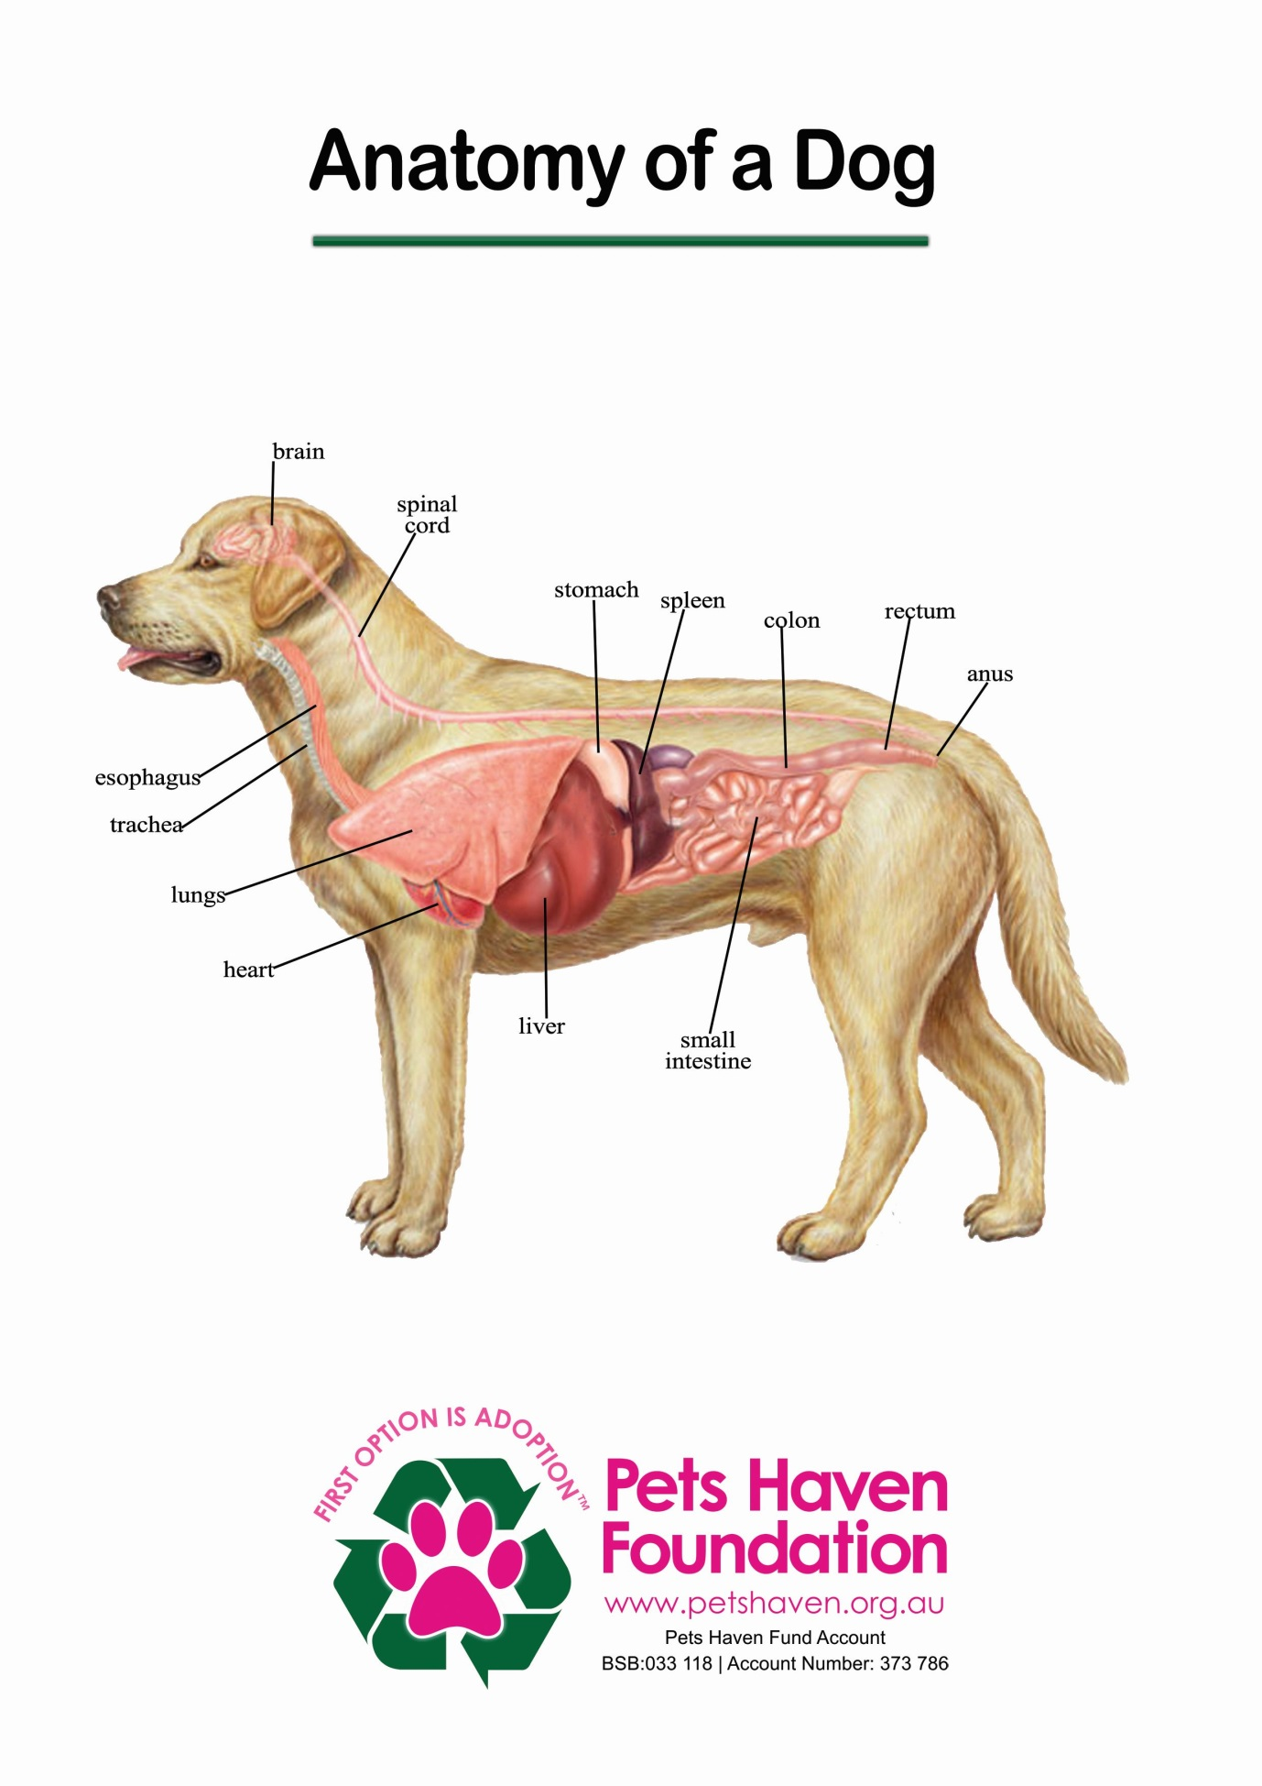

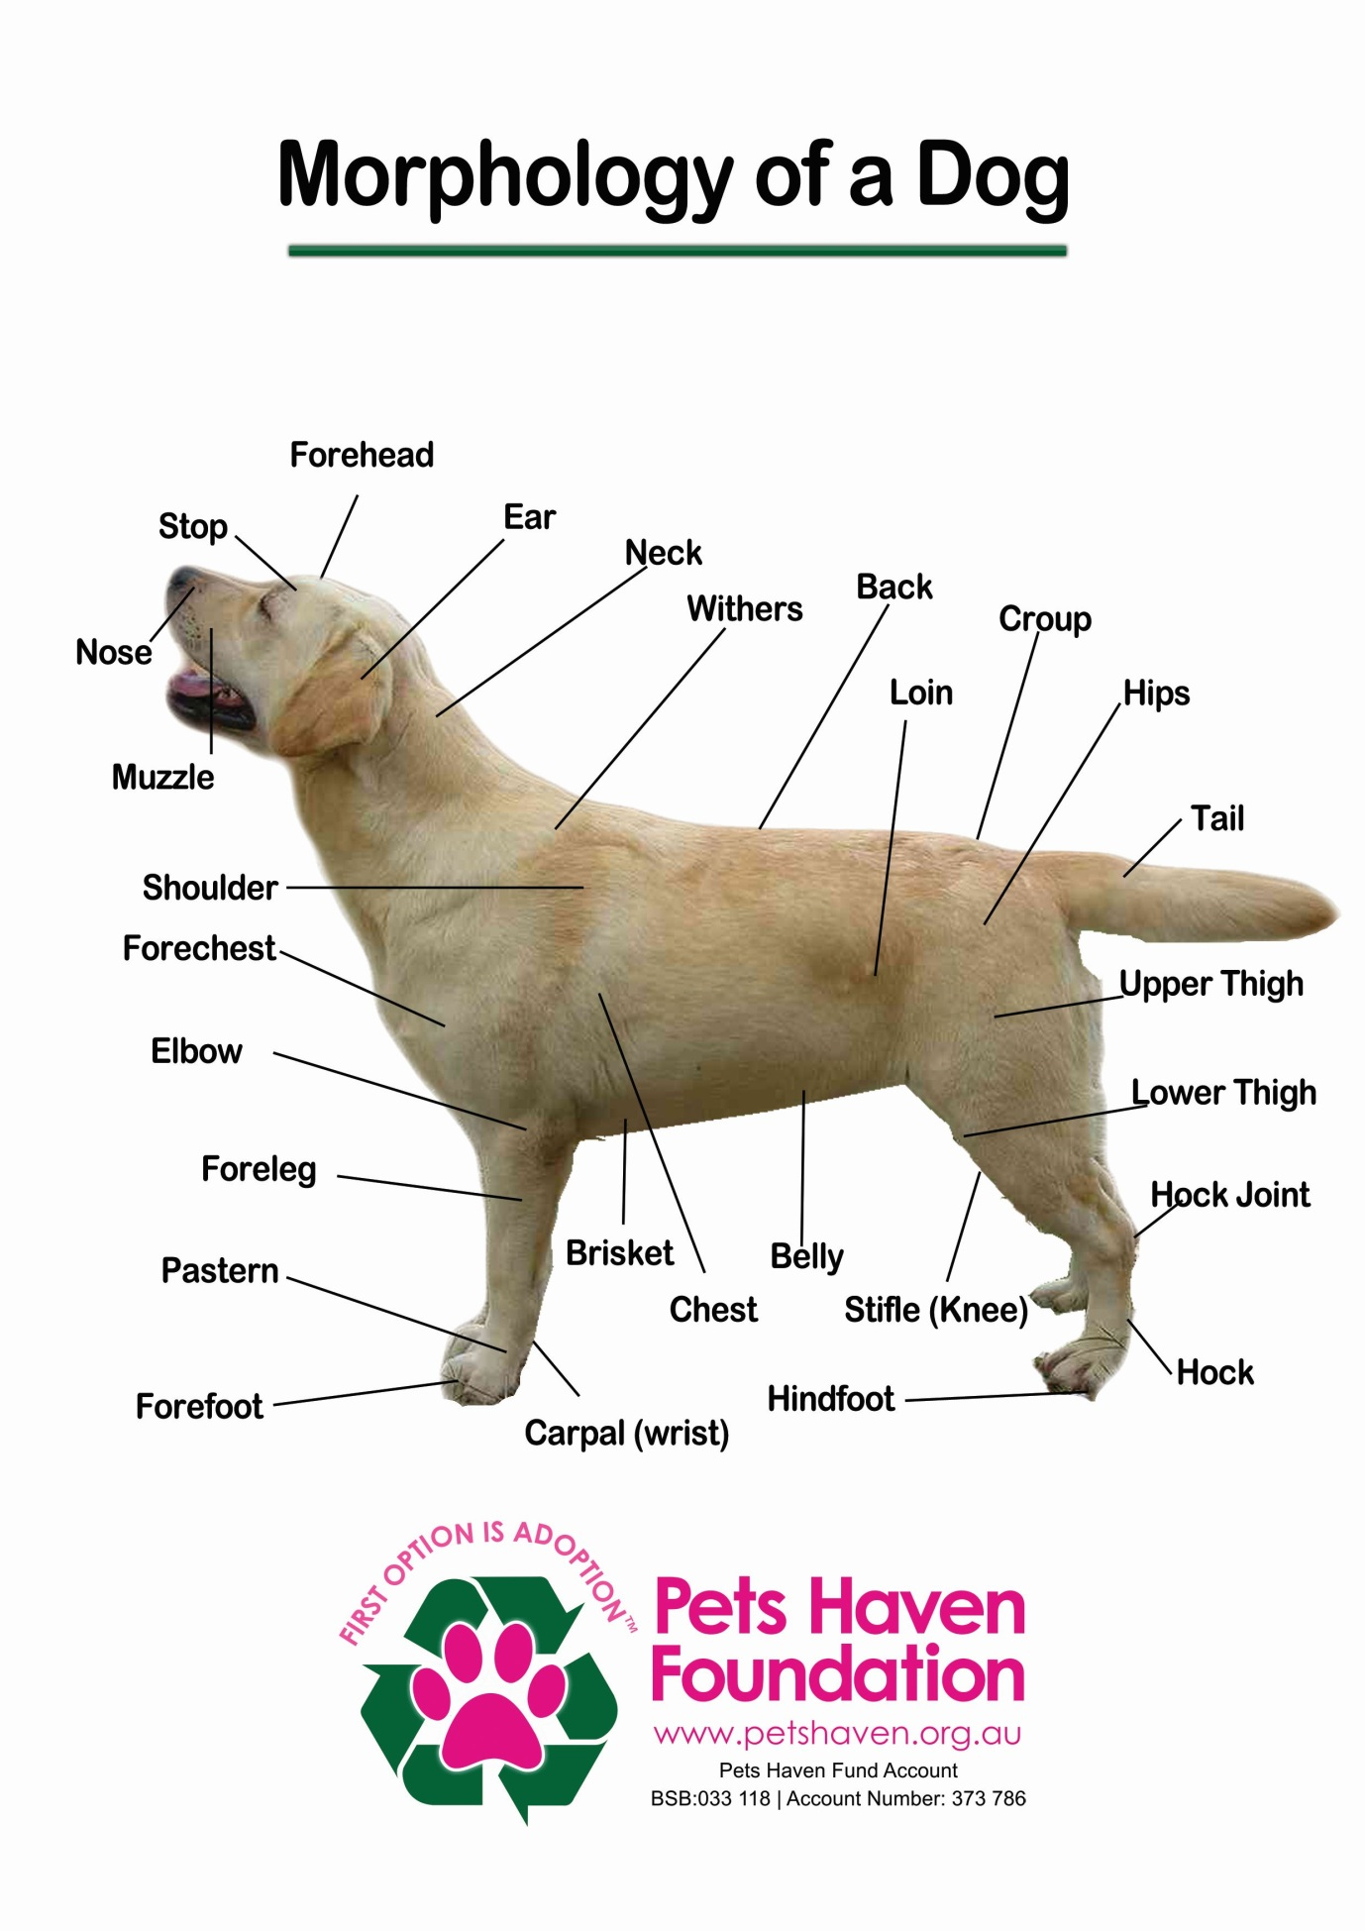

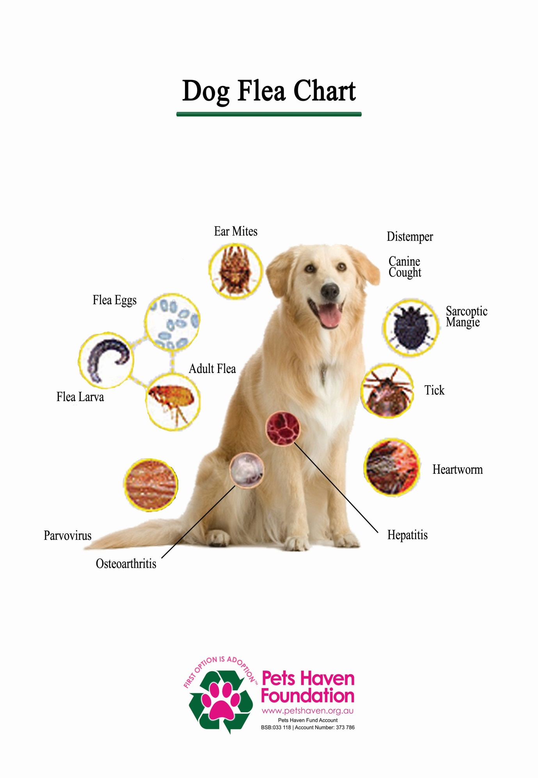

Basic Supply list for Foster Dogs
Bed or Sleeping Area
You can make your own bed/sleeping area by utilising a towel or blanket. This bed should be placed in a quiet place away from the high traffic areas of your home.
Water and Food Bowls
Each animal in your home should have their own food and water bowl. Stainless steel bowls are best for dogs, but plastic or ceramic bowls can be used.
Toys
Toys must be safe, but they don’t have to be expensive! Avoid toys with sharp edges, or ones that have small parts that your fosterling could swallow. Rope toys should only be used with supervision, as they can easily be ingested. Kong toys are great because of their interactive quality, great bounce, and easy clean up.
Leash and collar
You must always walk your foster dog on a secure leash and collar. Ensure you never allow our foster dogs to socialise with community members dogs. If a dog fight occurs or even if death results, this would have been something you could have prevented by simply following our guidelines.
Brushes and combs
Grooming is an activity that provides multiple benefits! It allows bonding time, a way to keep current of your fosterlings current general health, and helps cut down on shedding. Sometimes you may notice that a long haired cat has numerous knots, by brushing daily you can help de-matt.
PICKING UP YOUR FOSTER ANIMAL
In most instances, our Foster Care Coordinator will notify you when we require foster care or you can visit our private FaceBook Foster page.
You may want to choose an animal that you are familiar with. Otherwise, our Foster Care coordinator can recommend one for you to take.
You may borrow extra blankets or other supplies you may need from the shelter.
LENGTH OF TIME
Short –term foster periods may vary from a couple of days to a couple of weeks, depending on the adoption rate at the shelter.
RETURN TO THE SHELTER
Our Foster Care coordinator will contact you when there is space available so you may return your foster animal.
When returning to the shelter, use the same return procedure for all foster animals.
It may be difficult for you to see your foster animal in our shelter environment after having all the comforts of home while living with you. In addition, you may feel anxious about the future home “your” pet will have. It is important to remember that you have made it possible for this and other animals to remain available for adoption and that you must trust the adoption staff to find the best possible home for your friend.
Caring For a Pregnant Dog
Check the pups frequently in the first 24 hours after whelping to make certain they are warm. Be sure each one is nursing – you may pick each one up to check for any physical defects. Be sure to check inside their mouth for a cleft palate – the roof of their mouth should be a solid surface. (If the mom shows any aggression towards you when you attempt this, call MCDS). Otherwise, for the first 10 days your only obligation to the mom and new pups is watchful supervision.
SIGNS OF A DIFFICULT DELIVERY: Call Pets Haven immediately if any of the following happens during delivery:
- If more than 20 minutes pass between puppies and the mother is having strong contractions. Pups will arrive at irregular intervals, anywhere from a few minutes to an hour. The entire whelping process could take as long as eight or more hours, and it is normal for the mom to eat the afterbirth. Do not become alarmed about delays in the whelping process unless she seems to be straining or having a weak contraction for a period of 1 hour without expelling a fetus.
- If you observe any evidence of unusual pain during the delivery, such as crying or excessive biting or licking of the hindquarters.
- If the pregnancy exceeds 70 days (as a foster parent you may not have this information).
- If there is unusual discharge from the vulva under the tail. Normal discharge is green, abnormal can be black, cloudy, or foul smelling.
- If there is normal greenish discharge without the birth of a puppy.
- If the dog shows symptoms of illness, like depression, vomiting, diarrhoea or weakness.
- After a week or so, remember to handle each pup briefly at least once a day to accustom them to people and being held.
SYMPTOMS OF LABOR: Symptoms that signal the onset of labour include: uneasiness of the mother dog, her loss of appetite, lowering of her body temperature and a yellowish secretion from her breasts.
PREPARATION FOR DELIVERY: Gather a large box, clean towels, bedding, and a hot water bottle (with warm water in it). Provide a clean nesting area for the delivery. A large box 2 to 3 square feet and 6 inches high lined with a clean towel is ideal for a small dog, while a corner of a room or closet, in a quiet place with a large clean towel or sheet is appropriate for large dogs. Handle the dog as little as possible.

THE DELIVERY:
Try not to disturb the dog during the delivery.
At the moment of birth, she will lie on her side and contort herself as the contractions become stronger and finally will expel the fetus. In normal births, the mother will extract the puppies from the natal sacks, sever the umbilical cord, clean the mucous out of the puppies’ nostrils, and lick them to stimulate and clean them.
If the mother is not cleaning the puppies after delivery, use a towel and remove any fluid from the nose and mouth. Then dry the puppy using a gentle rubbing action.
Occasionally the umbilical cord will not separate from the mother and puppy. If this occurs, take a thread and tie a knot ½ inch from the puppy’s belly, and then cut the cord with the scissors between the knot and the mother dog. This will prevent bleeding if the cord tears.
If a puppy is not breathing, continue to stimulate the puppy by rubbing it vigorously; at the same time blow into its nose every 5 seconds to give it air. Try this for at least 5 minutes.
The puppies should be placed at the mother’s breast to ensure they nurse. Keep track of any puppies that do not nurse; they may need to be hand fed.
If the puppies cry, they may be hungry, cold, or sick. Contact Pets Haven if the crying persists.
Pups need foster care until they are 8 weeks old. That is the youngest age at which it is safe to desex them and they must be altered before we can place them up for adoption. When you return your puppies for their desexing surgery, that’s the end of your foster period for that animal and a job well done. Foster periods usually last for 2 to 4 weeks (although it depends on the age of the puppy) and foster homes are vital to these pups.
Pets Haven provides medical care for all foster animals. Since we’re the organisation responsible for these animals, it’s important that our veterinarians make all the treatment decisions about them. Please note if you take your foster animal to a private vet, we will not be able to reimburse you for any medical costs.
Some Things to Consider
Puppy Fatalities
Something to be aware of before you begin fostering is that sometimes foster animals become ill and pass away in foster care. This is the hardest thing about fostering and if this is a possibility you don’t think you’d ever want to risk encountering, and then perhaps volunteering at our shelter and working with the dogs and pups there might be a better volunteer fit.
We do everything we can for every litter; most of the time, that’s enough for them to become big enough to go up for adoption. Sometimes it is not enough, but at least we gave that pup a chance and provided the very best care we could.

Letting Go
When puppies thrive, sometimes you’re faced with another challenge: it can also be hard to let go and return your pup to the shelter to be desexed and then go up for adoption. You can always adopt a foster animal (regular adoption requirements and fees apply), but please think about whether or not you’d have difficulty returning a foster puppy before beginning to foster. Much as you might like to, it would probably not be feasible for your household to adopt every single puppy you foster!
Medical Concerns
While the shelter checks puppies over to make sure they appear healthy upon arrival, most illnesses have an incubation period between exposure and the onset of symptoms. Please watch your foster dogs carefully for any changes in their normal behaviour or habits. If your foster animal shows these symptoms, please call the shelter.
Fostering Puppies
Before You Bring Puppy Home. Where should the puppy stay?
House them in a small room, such as a bathroom, that you can keep closed off from the rest of your house.
The room should have adequate heating or cooling and good ventilation. It’s fine to have older puppies visit with the family in the rest of the house, but rest time and night-time should be in the designated room.
You can use a crate though it must have ample room.
What will I need?
You will need the following items to set up an appropriate space for your foster puppy:
Food bowl for dry food
Food bowl or saucer for canned food, if offered
Water bowl
Basket for bedding
Bedding – Old towels, sheets or blankets
Newspaper – To line carrier, and spread around the room.
Tarp – Can also be useful for protecting floor.
Toys – Chew toys (Kongs,) or tennis balls. Avoid toys that puppies can pull apart or potentially ingest, such as stuffed animals or rubber toys. Never give your foster real bones; they splinter and can be fatal when ingested. Also avoid rawhides, pig ears, or other chew treats that can be ingested in large chunks. They can swell in the dog’s system and lead to blockages.

Puppy –proofing
Remove any potentially toxic plants, or hang them out of reach.
Close toilet bowls.
Check for exposed electrical cords.
Remove breakable items that could be knocked off shelves.
Remove small, ingestible items.
Foster puppies and your pets
Be certain your resident pets are up to date on their vaccinations. This is for their own protection, as well as for the protection of foster puppies.
All puppies under 6 weeks should be kept completely separate from your resident dogs.
If you have a mother dog and puppies, do not let your pets near her when she is with her puppies; she is apt to be very protective.
If your foster puppy is ill, she should be kept completely separate from your resident dogs.
If your foster puppy is over 6 weeks and healthy and you have a friendly resident dog(s), you can introduce them slowly under your supervision, if you understand the health risk involved to your resident pet and are comfortable taking it. There’s always a chance that the pup could transmit illness to your resident animal. Bear in mind that while Pets Haven Foundation provides all the necessary vet care for the foster animal, we cannot pay for having your resident animal treated, even if you think your pet contracted an illness from the foster animal. Direct interaction between 6-week old and older puppies and your resident animal is therefore at your own risk and digression.
Wash your hands with an anti-bacterial soap after handling your foster puppy, whether or not she is ill. This will help prevent spreading known or unknown illnesses to your resident pets.
Daily Care
Feeding
Fresh water should be available at all times
Four weeks
Puppies with mom will be still nursing at this age, though mom may be beginning the weaning process.
Begin introducing solid food. Place some canned food mixed with a little bit of warm water in a low-sided dish or saucer. If mom is present, the puppies will generally follow her lead in eating the food. If they’re on their own, they may prefer to lick the food from your fingers at first, until they start getting the idea. If this doesn’t work, you can try rubbing the food on their teeth.

Five to six weeks
Feed canned food 4 times a day. Thin slightly with warm water if needed.
Introduce dry puppy food gradually. You can soften the dry food at first by soaking it in water. Puppies should be eating dry food well by the end of their 6th week.
Seven to eight weeks
Offer dry food 3-4 times daily. Supplement with canned food if desired.
A good way to keep puppies occupied and allow them to exercise their chewing drive is to put canned food in a Kong, and then freeze the Kong. Once the canned food is frozen, you can give it to the puppy. They will be able to eat the food as it thaws.
Adolescents (2 months to 1 year)
Feed dry puppy food 2-3 times daily.
Frozen Kongs are a good way to keep adolescent puppies occupied (see above).
Nursing mothers
Feed dry puppy food 2-3 times daily.
Feed canned food twice daily if mom is not maintaining weight with dry food only.
Fleas
Puppies over 4 weeks and adult dogs will be treated with Frontline or Advantage, the required Flea product is and can/will be supplied by Pet Haven.
If you have a puppy less than 4 weeks with fleas, use a flea comb a few times a day to remove fleas. Bedding should also be washed daily until fleas are gone. You can also give young puppies a sponge bath with baby shampoo to help remove fleas and flea waste. Be certain puppies are dried thoroughly afterwards.
Medical Care
Some foster puppies may be on medication when you take them home. Please follow medication directions carefully.
If you are required to give your puppy medication, the easiest way to administer pills is to hold the puppy securely, open her jaws, and then place the pill as far back in her mouth as possible. After you have placed the pill in her mouth, you may want to tilt her head back slightly and hold her jaw shut for a few moments to prevent her from spitting out the pill.
If your puppy as an upper respiratory infection, it is often beneficial to take the puppy into the bathroom with you while you take a shower. The steam helps ease congestion. You can also put a humidifier in the room where the puppy is being housed.
If you puppy is suffering any of the below, please take the appropriate action.
Diarrhoea – If stools are soft but not watery, monitor for two days. If there is no improvement, call the third day. If stools are watery, call that day.
Vomiting – If foster vomits food two or more times, call that day. If foster vomits bile or liquid, please call that day. If vomiting is frequent, call immediately.
Loss of appetite – Can be normal the first day as foster adjusts to a new home. If foster is not eating the second day, call that day.
Dehydration – Dehydration is generally associated with diarrhoea, vomiting, and/or loss of appetite. To test for dehydration, pinch the animal’s skin gently. If the skin springs back slowly, (takes more than one second), the puppy is dehydrated. Call immediately.
Sneezing – More than three times a day, call that day.
Coughing – Call immediately.
Hair loss – Call immediately.
Itchy/dirty ears – Call that day.
If your foster animal is on medication but is getting worse or not getting better as expected, please call immediately.
Some animals do not show traditional signs of illness. They may be less active than normal, or avoid other animals or people. These could be signs of onset of illness.
Please call us if you notice any of these changes.
If you have questions or concerns about your foster animal, please call Pets Haven.
Socialisation and Training
Socialisation
Spend as much time as much time as you can each day with your foster puppy.
If you have the mother dog, be sensitive to her natural protectiveness.
Foster puppies 4 weeks and older should want to play with you. Sit on the floor with them, pet them, and play with them. Discourage overly rough play with people.
Accustom puppies to different sounds, such as the TV, vacuum cleaner, and telephone. Introduce potentially scary experiences slowly and in small doses.
Accustom puppies to handling-touch their paws, stroke their bellies, lay them on their backs, look at their teeth and ears, and trim their nails.
Accustom puppies to different experiences-take them on car rides, bring them to a friend’s house (only if they have no dogs or have fully vaccinated, healthy dogs), and introduce them to children and other adults. Again, introduce potentially scary experiences slowly and in small doses.
Housetraining
Housetraining can begin at 4 weeks. Put a pile of newspapers in the corner of the room I which you are keeping the foster puppy. This is a good place for the puppy to go to the bathroom if you’re not home for a couple of hours. After each feeding, place the puppy on the newspaper or take her outside. Be patient! She may not remember to do this every time, or may forget where to find the papers, but she will learn quickly. Be sure to give the puppies lots of praise when they first start using their papers or ask to go out. It is a good idea to confine the puppies to a relatively small space, because the larger the area the puppies have to play in, the more likely they will forget where the papers are. Keep the papers clean and away from their food.
When you’re interacting with your puppy, keep a close eye on her for any signs she needs to eliminate. As soon as you see any signs, take her to the designated toileting location. In addition, take the puppy to the designated toileting location every hour. As the puppy gets older, the amount of time between toileting trips will increase.
When you’re home but unable to give the puppy your full attention, keep the puppy in a crate next to you or on a leash. Again, if you see any signs that she needs to eliminate, take her to the toileting location.
At night, put the puppy in its room or in a crate to sleep. Take the puppy immediately to the toileting location first thing in the morning.
Mouthiness
It’s important to discourage mouthiness-what’s not so bad at 6 weeks can become a real problem at 6 months.
If the puppy wants to mouth you or your clothes, gently close your fingers around the puppy’s muzzle, and firmly tell her “off”.
You can also employ “time-outs” if the puppy becomes over-excited and mouthy.
Leave the room or ignore the puppy for a while, perhaps giving the puppy something acceptable to chew instead.
Chewing
Puppies need to chew as part of the teething process. Provide plenty of chew toys (Kongs,) to encourage chewing on acceptable objects.
Carrots, apples, and ice cubes are also good for satisfying the chewing drive.
Make sure puppies don’t have access to articles they are not supposed to chew.
Spray off-limit items with Bitter Apple, a bad-tasting product available at most pet stores.
If you catch a puppy chewing an off-limit item, shake a can filled with coins or pebbles to startle and discourage the puppy.
Keeping puppies confined in a crate or in a small room when you are not present will also help prevent their chewing off-limits objects.
Behaviour Red flags
If you see any of the following behaviours, call Pets Haven as soon as possible:
- Growling, lip curling, snarling, snapping, or biting directed toward a human.
- Possessiveness, tension or guarding behaviour around items the puppy values, such as the food bowl or toys
- Reluctance to be touched or handled on certain areas of the body. Signs to watch for are nipping, whining, fearfulness, a quick whip of the head to look to see what you’re doing, or stiffening of the body.
- Fearful or aloof behaviour with strangers.
Letting Go
Returning your foster to Pets Haven to find her “forever” home is one of the hardest -but also one of the most rewarding -aspects of being a foster parent. Your foster puppy is ready to come back when she is at least 8 weeks if she was underage or healthy if she was sick or more sociable if she was shy. The Foster Coordinators should have given you an estimated date of return when you picked up your foster puppy.
If you decide you just can’t part with your foster puppy and you want to adopt her, please inform the Foster Care Coordinator before your scheduled return date. Your puppy will still need to be desexed, and all the normal adoption fees and adoption counselling will apply.
It is normal to feel sad when you return your foster puppy. You need to remember what a wonderful thing you did for your little foster. You have gave her your time, your attention, and your love, and you made it possible for her to go to a new loving home with a family of her very own. You are a very special person to have done all that for the little stranger who came to your door.

CATS
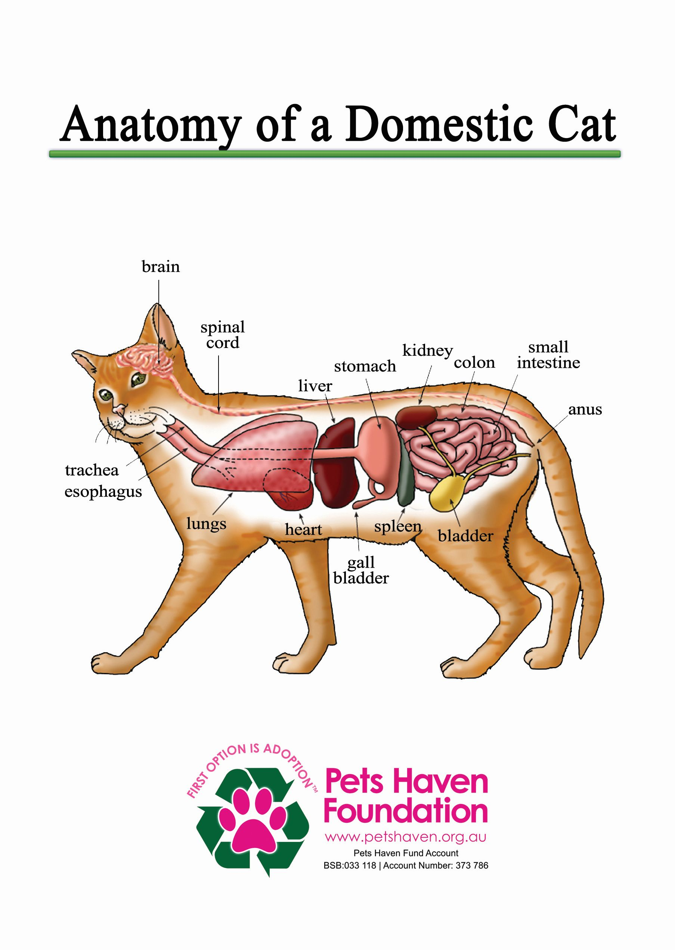
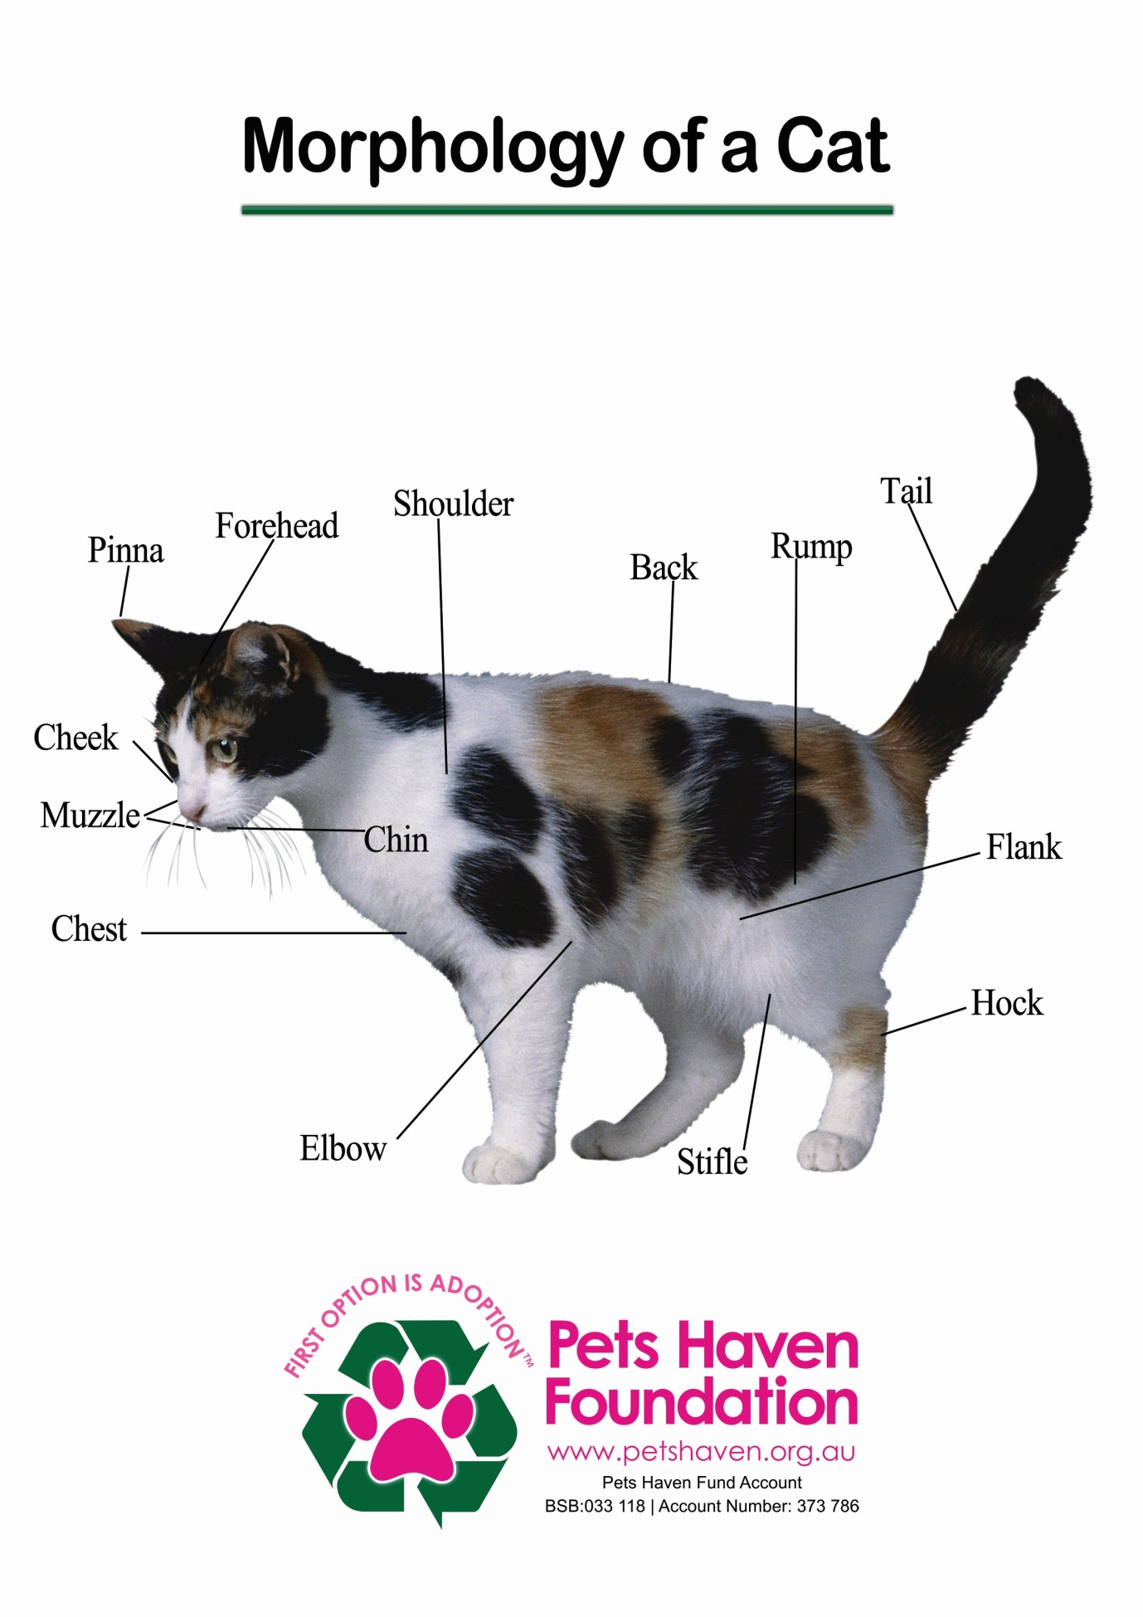

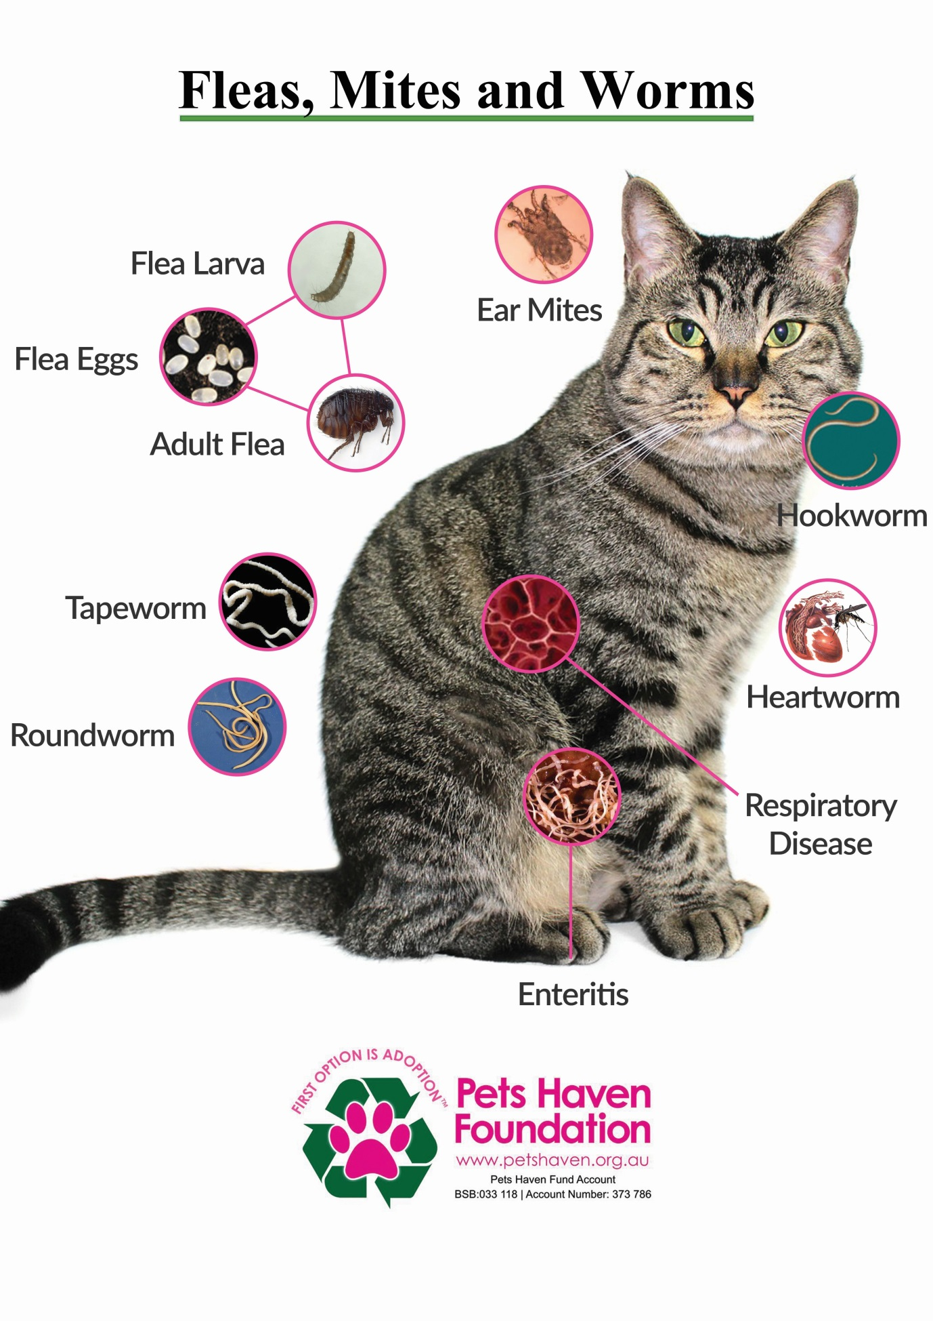

Common Cat Foster Situations and Descriptions

There are many different foster opportunities available. Below are some descriptions of our most common needs, though there may be more and different opportunities at any given time. Foster lengths will vary with each animal.

Mother Cat with Nursing Young

Sometimes we will have nursing mums dropped off at the shelter with their kittens either as strays or surrenders, or a cat will give birth while already here. Mum will need to be kept with her kittens until they are weaned around 6 weeks of age, and the kittens will need to remain in foster until they are ready for surgery and adoption (around 8-9 weeks of age).

Bottle Baby Kittens

Occasionally, we may get newborn kittens into the shelter that do not have a mother and will need to be bottle fed until they are able to eat on their own. These little guys generally require round the clock care, including overnight feedings, until they are at least 2-3 weeks old. They will not be very mobile or able to eliminate on their own until they are at least 3 weeks old as well, and will need to be kept warm at all times.

3-5 Week old Baby Kittens

These little ones are just past the bottle feeding stage and have just started eating on their own around 3-5 weeks of age. A smooth mix of food, smooth mix refers to a mixture of canned kitten food and kitten formula as they may not be able to eat the dry food on their own and will just be learning to drink water on their own as well. They will sometimes need some assistance via syringe or supplemental bottle feeding until they really get the hang of it, and will require at least 4-5 daily feedings until they are eating more consistently on their own. They should be starting to use the litter box on their own, but may need some help with that at first as well. They will usually require 4-6 weeks in the foster home.

Underage Kittens

These kittens will be about 5-8 weeks of age and should be fully weaned and eating completely on their own and generally be pretty good with the litter box. They will usually be pretty independent and playful and will only require two wet food feedings in addition to their dry food. They will usually require about 2-3 weeks in foster depending on their age.

Under-Socialised Cats/Kittens

These kitties can vary in age and need some work learning how to fully trust people so they can become adoptable. Some will have come from hoarding situations and may never have known people before, and others just may be very shy. They will require a lot of patience and work with safe handling techniques to properly socialise them. The time in foster will be extremely variable depending on how easily they are able to be socialised. Please never volunteer to foster scared kittens if you are time poor.

Sick, Injured, Surgery Recovery, Break from Shelter Cats

These are many various scenarios that we may have a need for. These kittens/cats can vary in age, temperament, and need level. Most just need some TLC until they can come back for adoption, or a comfortable place to live out their days due a terminal illness. We will give complete instructions for their care both in the home and any necessary follow up back at the shelter. The time in foster will be extremely variable depending on the reason for foster.

Necessary Cat/Kitten Foster Supplies

We will always provide all necessary medical care, including medications and vaccinations for all foster animals; though all medical issues need to be seen by the shelters preferred clinic unless otherwise arranged through our Foster Care Coordinator. Below are additional supplies you will need for your foster kittens:

Suggested Supplies to Keep on Hand

- Dry Kitten and/or Cat Food
- Wet, Kitten and/or Cat Food – avoid Fish varieties because of sensitive kitten tummies.
- Kitty litter – Change entire litter box daily.
- Litter Box or Boxes – different sizes/heights, Kittens need smaller litter trays
- Food and Water Bowls
- Old Towels, Blankets, and/or Cat Beds
- Kitchen Scale – to keep track of weight gain.
- Digital Thermometer, Rubbing Alcohol, and Vaseline – to take temperatures!
- Newspaper or Puppy Pads
- For under the litter box while they are still learning to contain messes.
- A Variety of Cat/Kitten Toys.
- Best to have them be completely washable or disposable (e.g. – plastic shower curtain rings, ping.
- pong balls, paper bags, paper towel rolls, plastic jingle balls, feathers on a stick/string, laser
- pointer, etc)
- Bleach to clean and disinfect the foster area during and after an animal’s stay

Additional Supplies that May be Needed

- Kitten Nursing Bottles and Extra Nipples
- Kitten Milk Replacer - Divetalac
- Syringes for supplemental feeding
- Snuggle Safe Discs or water bottles supplemental heat
- Whelping Box for Nursing Mothers
- Gardening Gloves to assist with Semi-Feral Handling

We are happy to provide any and/all of the necessary supplies (including all those listed above), though we ask our foster parents to provide as much as they are willing and/or able to. Fostering should not be a huge financial burden. If you are unable to provide any of the supplies necessary, we will do our best to accommodate your needs. Please clean and return any borrowed supplies at the end of the foster period.

Purchased Supplies

If you are able to provide any of the basic supplies necessary for your foster animals, we greatly appreciate it. But if you cannot we are more than willing in helping you.

Providing a Safe Home Environment

The Safe Room

Choose a space that is free of things that can hurt a kitten. The temperature should be able to be easily regulated to keep the environment at an appropriate temperature for kittens. It should also allow you to fully isolate your foster kittens from your own pets, as some kitten illnesses are transmissible, and occasionally fatal, even to grown cats. The room in which your foster kittens are living should be able to be easily cleaned and disinfected. You should also be prepared for litter box accidents, vomit, and spilled medicine. A spare bathroom is often a perfect space for fostering.

Kitten Proofing

Kittens are very adorable and can appear innocent, but are still very much babies and will try to get into everything if given the chance. It is important to keep windows closed, block any electrical outlets, cover, hide electrical cords, and put away anything that a kitten could swallow or get tangled in. Make sure to remove any breakable items or other things you don’t want ruined by the claws and/or teeth of a growing kitten! It is also very important to block any small holes or areas where a kitten could get into and become inaccessible to you. It will help to lie down on the floor on your stomach to see the room from a kitten’s point of view.

Suggested Set-Up

Your kitten room should contain everything that the kittens will need to eat, drink, eliminate, sleep, and play:
Have at least one bowl for water, one for wet food, and one for dry food. It may be better to provide more bowls if you have several kittens so no one has to compete for access to their food.
Litter boxes should be placed as far away as possible from food, water, and bedding.
Be sure to provide enough litter boxes that everyone has a clean place to eliminate – may need at
least 2 boxes for 4 or more kittens.
Old towels/Blankets tend to work very well as bedding. Just be sure they do not have long strings or large holes in them where the kittens could get tangled or stuck.
It may also be a good idea to have a secure sleeping area, such as a cat carrier with the door removed, or a cardboard box on its side. This will help the kittens feel safe, and can be especially important for shy kittens.
Provide safe, disposable or easily sanitised toys to entertain the kittens when you are not with them. Plastic jingly balls, ping pong balls, wine corks, plastic shower curtain rings, or balls of paper/foil can work well.

Importance of Isolation

While we know that you just want to let your foster animals roam your home and play with your own animals, it is definitely best to keep them isolated until you feel comfortable that nothing detrimental will happen.
The goal is to keep everyone happy and healthy and to keep any issues that may arise contained. We may occasionally recommend that you socialise your animals with your fosters (with dogs it is usually unavoidable), but it is important to isolate them at first for the following reasons:

Disease Prevention

Known Illnesses - If your foster animal is sick when they get to your home, it is best to keep them isolated so they do not infect your resident animals, and so they do not spread their illness all over your house leaving the possibility of reinfection later on.
Possible Illness - Most communicable diseases will pop-up within 14 days. Kittens can appear healthy, but may be carrying something that could develop within that time frame. By keeping everyone separated and confined to a smaller area, you are insuring that they are not able to spread disease to any other animals or areas of your home which can make treating and permanently getting rid of the disease(s) much easier.
Intestinal parasites can both be caught and transmitted through the litter box. Fosters should not
share the family litter box, and your cat(s) should not have access to your foster animal’s litter box.

Stress and Behaviour Issues

Adult Cats - Most do best if they are slowly introduced into a home environment; especially after having lived in a shelter. The sudden access to the space in a big house can be very overwhelming and cause them to get lost and/or hide or have issues getting to and using the litter box. Just as we recommend with a newly adopted cat, foster cats should have their own space for a few days to allow them to acclimate to the new environment, and be slowly allowed out into the rest of the house.

Nursing mums They can be very protective over their litters and need a quiet place to nurture and raise them until they are ready to be weaned. Too much space and exposure to other animals can lead her to continually relocate her brood or just stop caring for them altogether.

Kittens May not seem to have much stress with their new environment, though they still need to be isolated. They are likely still getting the hang of the litter box, and having too much access far away from it may cause them to go somewhere else because they were unable to find their way back. Additionally, their safe room will be free from hazards and hiding places, whereas the entire house may not be safe for them and they could get trapped under or behind furniture.

Resident Animals

Your own animals may seem to do well with the addition of new foster animals, but it can be stressful for them to have new friends continuously come in and out of the house. Keeping the foster animals isolated help to eliminate some of that stress, but can also prevent negative interactions between them which can be more damaging to both your animals and your fosters.

.org

Daily Care and Health Monitoring

It is very important to monitor a kitten’s health and weight on a daily basis regardless of age – though it is VITAL in a bottle or smooth fed kittens. We can provide a Daily Check sheet for each animal where you can record their weight, eating habits, and overall health. If you do not have a kitchen scale, we can provide you with one for the duration of the foster period so that you can easily track their weight.

Weighing your Kittens

A kitten’s weight can be one of the best ways to track overall health. If they are either losing, or not consistently gaining weight, it can be an indicator of an underlying problem, even if you are not seeing any other apparent issues at the time.
Please ensure you regularly [weekly] weigh kittens and supply the weights to our Welfare Manager.
**Any weight loss in a =you have a serious concer
Feeding

Most fosters will not have a special diet, but we still want them to remain as consistent with the shelter diet as possible. We are always happy to provide their food if necessary, but if you decide to donate the cost of their food, we ask that you feed a good quality food whenever possible (or a mixture of Premium food and other food). All cats have sensitive digestive systems and can have bad reactions to a sudden diet change, and some human foods can be toxic to cats. Kittens are particularly sensitive to sudden diet changes, and keeping everything consistent can help prevent many issues.

If your foster kittens are refusing to eat the food you have provided, it could just be them being picky or stressed, but could also be a sign of a bigger problem. Please call Pets Haven if your foster kittens have not eaten in 12 hours – sooner for a bottle or smooth fed kitten.

Daily Care and Health Monitoring

Daily Duties

Feed 2-3 times per day or more
Discard and replace if there is litter, feces, or other contaminants in the existing dry food.
Feed each kitten/cat wet food according to their age

For Adult Cats:
Feed the appropriate amount of dry food as listed on the Foster Animal Info Sheet and/or on the feeding chart on the Cat/Kitten Feeding Protocols sheet.
Clean bowls and Supply fresh water.
Throw out the previous day’s water, clean the bowl, and add new water every day
Be sure to thoroughly clean bowls if there was any litter, feces, or other contaminants in either the water or food bowls.
Clean the litter box and check urine/stools for any obvious issues (blood in urine, loose stools, vomit in or near litterbox, etc)
Change out the litter fully every day if you are using non-clumping pine or clay litter.
Scoop the box daily if using clumping litter
Be sure to contact the Pets Haven with any concerns.
Look inside mouth at gums and teeth to be sure gums are pink and hydrated (not tacky or sticky)
Check litterbox for diarrhoea/loose stool, blood in urine, etc
Check energy levels and interest in food/water
Contact the Pets Haven if anything is abnormal or concerning.

Socialisation, Handling, and Playtime.

Kittens have a lot to learn and should be played with for 20 minutes or more, 2x daily – more for under-socialised kittens
Use a variety of toys, and try to encourage them not to use their claws or teeth on people, and remember to discourage play with hands.
Encourage affectionate behaviour, and have them meet new people as often as possible
Get them used to being picked up, and gently handle paws, ears, tummy ect
Most kittens will benefit from exposure to brushing/grooming in small amounts. Keep written record of the foster’s weight, food intake, and medications given.

As needed duties:

Weigh animals every other day for very young, once a week for older animals.
Clean Bedding/Dishes/Litterboxes
All bedding, food/water bowls, and litter boxes should be thoroughly cleaned at least once per week
Write down all dates that vaccines and de-wormer are due on your calendar, check regularly, and make appointments with the Foster Care coordinator if needed.
Check your food and litter supplies and call Pets Haven if you need more.

General Cleaning Procedures

Kittens can create quite a large mess in a short amount of time. It is suggested that your isolation area for cats and kittens be in a room without carpeting for ease of clean up and disease prevention. If you only have a carpeted area, we suggest placing a tarp or shower curtain liner securely underneath any bedding to make cleanup easier.
You will need to regularly clean the foster area, as well as fully disinfect it between fostering different litters.
Keeping your foster area clean will serve several purposes while your foster animals are in your care.
Keeps foster animals cleaner and more comfortable
Be able to identify any issues (e.g. – diarrhoea, vomiting, etc) more quickly
Significantly reduces the spread of disease

Routine Cleaning While Foster Animals are in Residence

You should plan to fully clean the foster area(s), including litter boxes, bowls, and bedding, at least once per week.
You can keep your fosters in a crate while cleaning and return them to the space once finished.
Hard Surfaces, Litterbox(es), and Bowls:
All surfaces (floors, walls, etc), litter boxes, and food/water bowls should be cleaned with a solution of gentle soap(e.g. Dish Detergent) and warm water at least once weekly. They should be thoroughly rinsed and dried prior to being returned to the foster area. Bowls can also be run through the dishwasher.

Bedding and other Soft Materials:

Bedding for foster animals should be removed and replaced at least 2x weekly (or more often if soiled with vomit, urine, or feces). Bedding should be washed in a washer with hot water, or the whites cycle, with detergent and bleach, but no fabric softener, to insure that is has been sanitised. We recommend using primarily old towels and blankets.

Cleaning and Disinfecting Between Groups or with Disease Outbreaks

Your foster area(s), and everything your foster animals used during their stay should be fully cleaned and disinfected after your foster animals have been returned to the shelter, or during/after a disease outbreak (e.g. – URI, intestinal parasites, etc) to prevent further spread of the disease}. Anything that cannot be washed and disinfected (e.g. – cardboard scratching posts, toilet paper tubes, etc) should be discarded and not used for any future foster groups. We suggest using bleach to remove any lingering disease or other contaminants. Be sure to remove any organic matter (fur, litter, dirt, etc) before using bleach.

Medical Care and General Health Concerns

All cats will receive a vaccination (as appropriate for their age), be microchipped, and
desexed before they can be put up for adoption. While all animals are checked for general health before going into foster, they may develop other health concerns along the way, and may need to be seen by one of our Vets.
Veterinary, all medical care for your foster animals will be provided by Pets Haven for the duration of the foster period, and until they are adopted. Unless previously arranged and approved, any medical care sought elsewhere will not be reimbursed. Additionally, we cannot provide any medical care for your personal animals.

Vaccine Boosters for Foster Kittens

Information about your kittens will be given to you when you collect your fosters from Pets Haven. You are obliged in following our procedures as to ensure that these kittens receive their vaccinations on time.

Desexing Surgery

All animals that will be available for adoption must be Desexed before they go to their forever homes.
Cats and kittens must be healthy and of the appropriate weight before they can be scheduled for their surgery. Most animals will not need to return to the foster home to recover from surgery and will be made available for adoption the following day. However,
Exceptions are certainly possible.
Eligibility:
_ Healthy
_ At least 7 weeks of Age and over 800 grams in Weight
_ Nursing Moms must be fully dried up from Nursing

Veterinary appointments:

Please contact our Foster care coordinator to schedule a surgery date once the eligibility criteria have been met for your kittens. We can schedule individual kittens, but we generally like to wait until the entire litter is ready before we alter anyone. Foster animals can either be returned to the shelter a day or two prior to surgery to our Intake

Signs of Sick Kitties and What to Do

Most kittens come into the shelter as strays, so we often do not know anything about their previous medical history. While they may initially appear healthy, they have fragile little immune systems and may develop diarrhoea or an Upper Respiratory Infection (URI), among other illnesses. Most are generally pretty mild, but can sometimes be life-threatening, so it is important to be very observant of changes in your kittens’ behaviour and isolate your fosters from your other animals. You must make contact with Pets Haven.

Diarrhoea

There are 3 different types of cat stool: normal, soft, and diarrhoea. Normal stool will be firm and well-shaped. Soft stool will still have form, but may be more cow-pie-like – this is the first sign of diarrhoea. If it gets worse and becomes completely liquid, then you have reached full blown diarrhoea. It can be caused by a variety of things (e.g. - stress, diet changes, or intestinal parasites) and is very common in kittens. The biggest concern with diarrhoea is dehydration, which can become a serious issue very quickly – Please be sure to let us know of any issues as soon as possible.

Emergency Situations
While rare, there is always the possibility of experiencing some kind of emergency situation with one of your foster animals. Kittens, especially, are fragile little beings and can have seemingly small issues become much bigger problems very quickly. Also, a seemingly perfect situation isn’t always perfect, and accidents happen. If you aren’t sure if it is a true emergency, err on the side of caution and give us a call. A false alarm is always better than a true emergency.
Please call our Foster Care Coordinator on 0417 835 066, if you cannot get through to her please contact the shelter on 5427 3603.
Example Emergency Situations:
Severe diarrhoea, especially in combination with vomiting or with a lot of blood in the stool
Severe lethargy or dehydration, laboured breathing
Gums will usually be very pale and/or sticky/tacky. Pressing on the gums will usually result in no colour change, or very slow colour return
Fading Kitten Syndrome (see below)
Runaway Foster Animal - If one of your foster animals gets out and you cannot find them, we want to be notified as soon as possible.
Accidental Injury – caused by another animal or some kind of trauma
Accidents will happen, and if they do, we want to be able to help that animal as quickly as possible.
Unconsciousness, seizures, uneven pupil dilation, or fainting
Unable to be roused from sleep, uncontrollable shaking of part of, or whole body
Fading Kitten Syndrome
A “fading” kitten is one that appears healthy at birth but fails to survive beyond 12 weeks of age. Death usually occurs because of one of the following reasons: congenital defects, low birth weight, nutritional diseases from inadequate diet fed to the mother, infectious diseases, lack of antibodies from the mother, severe parasites, etc.
Unfortunately, kitten death due to “fading” is not uncommon. Symptoms usually include sudden and continuous lack of appetite, increasing lethargy, or sudden death. Usually the circumstances are unavoidable.
Remember it is not your fault
By being a foster parent you are giving an animal every opportunity to survive.
In the unfortunate event that one of your foster animals passes away…
If an animal does pass away in your care, Pets Haven needs to be advised immediately.
Fostering Under-Socialised Kittens
Under-socialised, neglected, and frightened feral kittens may be the most challenging shelter animals to foster, but can also be one of the most rewarding as you watch them transform. These guys will need a lot of TLC and handling to help them become happy and social kitties. These kittens may not have been inside a house or car, been litter trained, or have experienced kindness from a human. These kittens are likely to be very frightened and may hiss and “spit” at people. The more ferocious the kitten acts, the more scared it is.
Unlike normal, social kittens, we recommend that feral littermates be separated from each other. When together, they may feed off of each other’s cues, and be much harder to socialize. Once they lose the protection of a group, they are forced to become a bit more self-reliant and are more likely to befriend people. We may also recommend that they join a friendly cat, kitten, or litter. They may be more comfortable around other cats, and being around a social cat will help them learn, and hopefully begin to emulate, appropriate behaviour with humans.
Home Environment
Under-socialised animals must be closely monitored to reduce the chance of escape or destructive behaviour. A quiet, confined environment is best for these kittens. A small space such as a dog crate or small bathroom works best. If they are confined to a room, make sure to block off hiding spaces so you can access the kittens without having to chase them and cause additional stress. However, it is still important to give the kittens a safe place to hide – such as a tipped over box with a towel inside.
When you first bring the kitten home, give them some time to acclimate to their new environment before attempting to handle them. The kitten needs to learn that their foster home is a safe place. Visit with them frequently, move slowly around them, and talk gently to them. Playing talk radio or reading aloud around them may also be a useful tool to help them associate people as a good, trustworthy entity. If possible, allow the kitten to approach you.
Handling
Consistent handling can be one of the most effective ways to get feral cats and kittens to become social and happy house cats. Some kittens will calm down the moment they enter the home, and handling will be easy from the get go, but others take more time to build their trust. It is very important to have many people handle the kitten so they do not learn to trust only one person. If the kitten is hissing, spitting, swatting, and/or growling, it is best to protect yourself with gloves and/or a thick towel to prevent them from being able to bite, and so you can approach them fearlessly. The best way to correct their defensive behaviours is by being gentle yet firm, and completely unafraid of the kitten, even when at their most ferocious.
It is generally easiest to pick up a super scared kitten by the scruff of the neck. This will slightly immobilize them and also give you a good hold away from their teeth. Spend as much time as possible actually holding the kitten, and maintain a gentle scruff until you are sure they will not try to get away. Talk to the kitten and gently pet them with your free hand, but be careful not to give the kitten the opportunity to bite. Let go of the kitten if it becomes too difficult to handle, but try to always be the one who ends the handling session. Give the kitten a treat or feed them immediately after handling. This will reward the kitten and hopefully reinforce the idea that good things come from people. Handle the kitten as often as possible throughout the day for at least 5-10 minutes each session
Feeding
Smelly and tasty food can be the gateway to a feral kitten’s heart and trust. They likely did not have regular access to food prior to being brought into us, and they are likely to appreciate regular meal times. If at all possible, try to hand-feed your kitten. At the very least, stand by as they eat so they begin to associate you with their food. We recommend Turkey and Chicken Baby Food as an enticing treat!
Know someone interested in one of your animals?
Sometimes foster parents know of people who might want to adopt their foster animal. Foster parents need to let these interested people know that they must go through the adoption process at Pets Haven Foundation.
Foster parents should inform the interested party to contact the intake desk to set up an adoption hold on the animal(s)*. There is a fee associated with this hold. If the animal is able to be adopted, they will be called by Pets Haven when the animal is made available. They will have 24 hours from the time the animal is made available to adopt. If they are still interested in the animal, they simply need to come into the shelter and go through the process described above.
If you, the foster carer, wants to adopt your foster animal, you will need to inform Pets Haven.

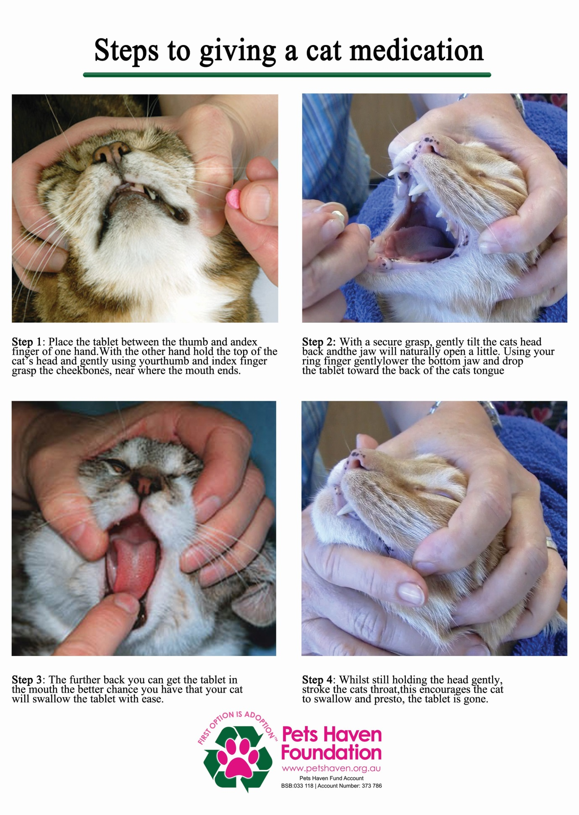

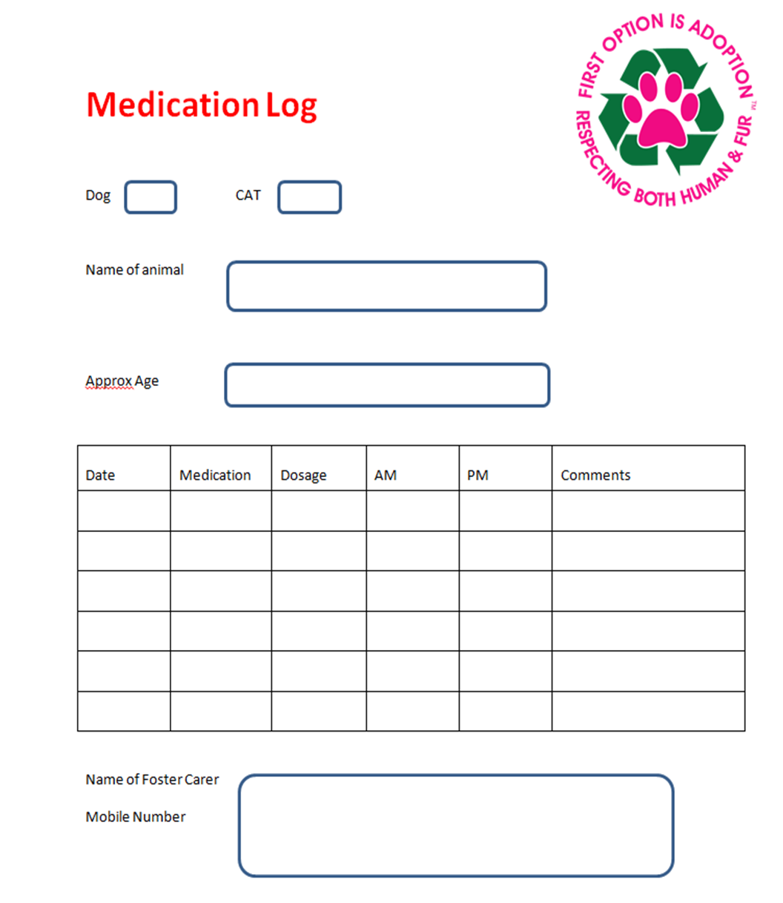

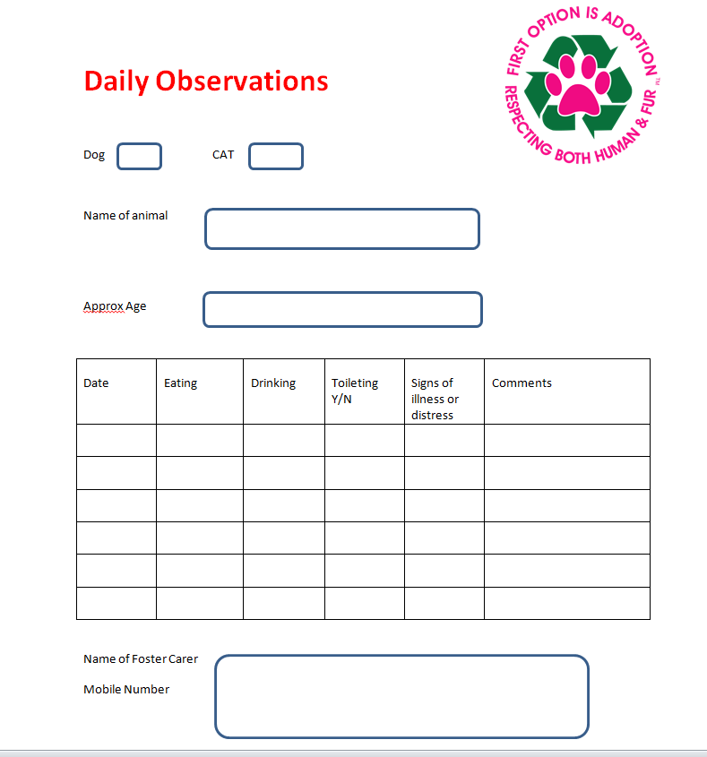

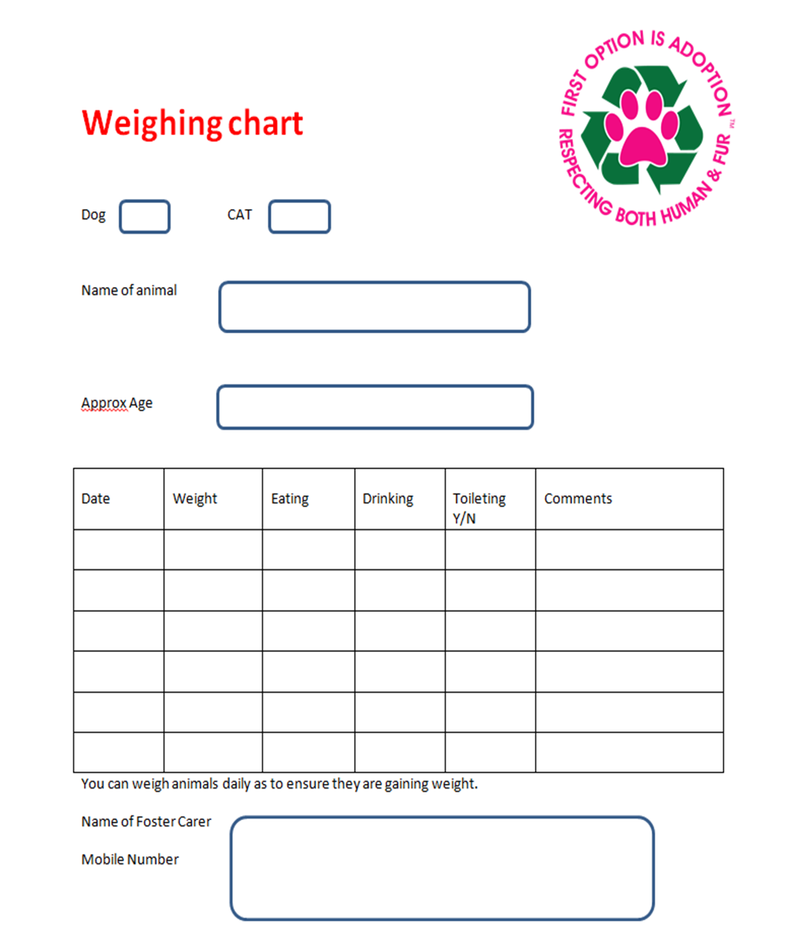

Pets Haven Foster Friends Application

Personal Information
Title
Surname
First Name(s)
Street Address
Postcode
Home Phone
Work Phone
Mobile Phone
E-Mail Address
Preferred contact method | Home Phone Work Phone Mobile Email
Date of birth | / /
Drivers Licence No

Your home
Please indicate how many people are living at your premises and their ages.
Adults – Age(s)
Children – Age(s)

Do you work?
No Studying Home Retired
Yes Full time Part time

Hours spent away from the home

Do you rent your home? No Yes If yes, are animals allowed?

Your pets
Do you currently have any pets in your household? No Yes
If yes, please list their breed and age
Pet’s name | Breed | Age | Desexed? | Are vaccinations up to date? | Where does this pet sleep? | Where does this pet stay when you are out?
 |  |  | No Yes | No Yes
 |  |  | No Yes | No Yes
 |  |  | No Yes | No Yes
 |  |  | No Yes | No Yes

Fostering Experience
Have you fostered before? No Yes

What experience have you had with animals that would be helpful fostering?

Where will your foster pet sleep?
Where will your foster pet stay when you are out?
Would you be able to keep the foster animal separate from your own if necessary? No Yes
If yes, where?

Fostering preferences
Canines:
Dogs Size preferred – Small Medium Large
I am able to foster: Puppies Mums and babies Sick dogs Dogs that need rehab

Do you understand that any pup under the age of 12 wks that has not been fully vaccinated must NOT be allowed out of your backyard for a walk or any other social activity. Also any dog of any age is NOT to be walked off leash at any time in a public area? No Yes
Do you agree in keeping the community and community dogs safe at all times? No Yes
Do you have secure fencing? No Yes
Please describe your fencing

Felines:
Cats Kittens
I am able to foster: Mums and babies Sick cats Cats that need rehab
Do you understand that ALL Cats and Kittens MUST be kept INSIDE at all times ? No Yes

Policy, Agreement and Signature

What do you do if the animal becomes un-well? If your foster animal becomes un-well or you are concerned in any way please contact our Welfare Manager during business hours 8.00am to 5.00pm Monday to Friday Serena Eldridge 0417 424 818. On Saturdays and after hours you may contact our veterinary clinic on TEL 9729 5444, Email clinic@petshaven.org.au of Facebook message @petshavenveterinaryclinic.

Our Welfare Manager might be able to help you on the spot or will authorise any medical visits required. You will then be required to take your animal to our Veterinary clinic 302/304 Canterbury Road Bayswater North.
If you decide to take your foster animal to any other vet, Pets Haven cannot reimburse your costs.

Do you agree? Yes No - If no, please give your reason

Foster Care Volunteer To Provide. I will provide the Foster Animal(s) with responsible care, including, food, water, shelter, and when instructed by Pets Haven, medication and/or training or socialization. I agree at all times to follow the instructions from Pets Haven with respect to the treatment and proper handling of the animal.
Do you agree? Yes No - If no, please give your reason

Medical or Age Related Placements. If the Foster Animal has been placed with me for medical reasons or due to the Foster Animal being of a young or old age, I understand that the Foster Animal’s care may require daily medication or medical care, periodic veterinary visits and physical assessments at PETS HAVEN. I agree to abide by the instructions of Pets Haven with respect to the Foster Animal’s care, to provide careful supervision of the Foster Animal’s condition, to report any medical concerns to the PETS HAVEN immediately, and to cooperate with PETS HAVEN with respect to making arrangements for bringing the Foster Animal(s) to the shelter when requested. In the event of a medical emergency, I will immediately contact the PETS HAVEN and follow the instructions provided. If an accident is caused whilst in my care, I shall be deemed responsible.
Do you agree? Yes No - If no, please give your reason

Training and Socialization. If the Foster Animal has been placed with me for socialization, training or other behavioral reasons, I acknowledge that (i) I have been advised by PETS HAVEN of the Foster Animals behavioral or training needs, (ii) I am willingly accepting the Foster Animal with knowledge of its behavioral or training needs and I represent that I have the ability to manage the Foster Animal. I understand and accept the risks that these behavioral or training needs may present, and I agree to follow the training or behavioral/socialization instructions provided by PETS HAVEN. I will maintain control over the Foster Animal at all times while in my care. I agree to make every effort to attend training programs with respect to the Foster Animal if deemed necessary by the PETS HAVEN Trainers and to bring the Foster Animal to PETS HAVEN for periodic assessments upon request.
Do you agree? Yes No - If no, please give your reason

Inspection. I agree that PETS HAVEN has the right to inspect my home upon reasonable notice, for the sole purpose of determining the on-going suitability of the premises for the care and maintenance of the Foster Animal(s).
Do you agree? Yes No - If no, please give your reason

Progress Reports. I agree to give weekly progress reports to PETS HAVEN with respect to the Foster Animal.
Do you agree? Yes No - If no, please give your reason

Foster Animal To Remain PETS HAVEN Property. I understand that the Foster Animals(s) will remain the sole property of PETS HAVEN and I acknowledge that I do not have any right or authority to keep the Foster Animal(s) or to place the Foster Animal(s) with any other individuals unless PETS HAVEN gives me permission to do so in writing. I agree to return the Foster Animal(s) to PETS HAVEN upon request.
Do you agree? Yes No - If no, please give your reason

Property Damage Do you understand foster animals, like any other companion animal in your home, may destroy carpeting, shoes, clothing and other valuable items. Preparing your home and the area the animals will stay in can prevent most accidents, but not all of them. Pets Haven cannot be held responsible for any accidents.
Do you agree? Yes No - If no, please give your reason

Termination by Foster Care Volunteer. I understand that I may at any time decide to terminate a foster care placement with respect to a particular Foster Animal by notifying PETS HAVEN of that decision. I agree to work together with PETS HAVEN to make arrangements for the prompt return of the Foster Animal to PETS HAVEN if I terminate this agreement. I understand I can decline to accept any foster placements.
Do you agree? Yes No - If no, please give your reason

Release/Indemnification. If accepted as a Foster Care Friend, I agree to follow the conditions of any foster placements. I also agree that PETS HAVEN, its officers, directors, and volunteers are not responsible for, and I release them from liability for, any losses, injuries, or damages that I may incur by participating in the Foster Care Program. I agree to indemnify PETS HAVEN, its officers, directors and volunteers for any damages and expenses they may incur in defending any claim by a third party as a result of my actions or inactions as a Foster Care Volunteer or of a foster animal while in my care.
Do you agree? Yes No - If no, please give your reason

Before you submit please read carefully: I have answered the questions above truthfully and completely. I understand that although PETS HAVEN takes reasonable care to screen animals for foster care placement, it makes no guarantee relating to the dogs' health, behaviour or actions. I understand that I receive foster care animals at my own risk and can reject or return any animals for which PETS HAVEN has asked me to provide care. I indemnify and hold PETS HAVEN free from all liability arising out of any and all claims, demands, losses, damages, action, judgment of every kind and description which may occur to or be suffered by me, members of my household, or any third parties by reason of activities arising out of this agreement.

The Foster Animal remains PETS HAVEN Property. I understand that every Foster Animal(s) I foster now or in the future will always remain the sole property of PETS HAVEN and I acknowledge that I do not have any right or authority to keep the Foster Animal(s) or to place the Foster Animal(s) with any other individuals unless PETS HAVEN gives me permission to do so in writing.

I agree to return the Foster Animal(s) to PETS HAVEN upon request Yes No

Wanting to adopt your foster pet and or a family member? Do you understand that anyone interested in adopting your foster animals (including yourself) must go through the standard adoption process? If you are fostering an animal with the view to possibly adopting, you must abide by all of the above mentioned rules. It is extremely important that you provide a secure environment and are a responsible carer. Do not place our animals in risk situations such as off leash parks, beaches or allowing our foster dog to meet community dogs. Until this animal has been legally processed, adopted and paid for from our facility, you must abide by all of foster care conditions. Please become very familiar with our veterinary procedures. If a medical issue arises you must not use your preferred veterinary clinic, you must contact Pets Haven. If for some reason you use your own veterinary clinic you will incur those expenses, which could add up to thousands of dollars. please ensure our procedures are followed. Additonally, our animals remain the property of Pets Haven until they are returned to our facility and/or legally adopted

Do you agree? Yes No - If no, please give your reason

Special Note: All foster placements from his day forward are subject to approval of PETS HAVEN and are at the sole discretion of PETS HAVEN and may be terminated at any time by PETS HAVEN. I agree to relinquish custody of the foster animal to a PETS HAVEN representative immediately upon request and authorize PETS HAVEN to enter on to my premises for the purpose of reclaiming the foster animal.

Do you agree? Yes No - If no, please give your reason

Thank you for taking the time to read this application please sign below to show you have read and agree to all terms and conditions

Name (printed)
Signature
Date

Our Promise
“We at Pet’s Haven Pro-Life Animal Shelter value our relationship with you and will treat any personal information we collect from you carefully. Pet’s Haven is bound by the National Privacy Principles contained in the Privacy Act 1988.”
Thank you on behalf of Pets Haven Animal Shelter for taking the time to fill out this form we will place you on our data base and when an animal relevant to your foster caring abilities comes up we will give you a call text or email.
In the instance you are not available we will simply ring the next person and contact you next time.

We reserve the right to refuse any applicant! Office Use Only
Date received

